Figure 6
Connections over 200 kbps in at Least One Direction 2016-2020
(in thousands)

 | 2016 |  | 2017 |  | 2018 |  | 2019 |  | 2020
Technology | Jun | Dec | Jun | Dec | Jun | Dec | Jun | Dec | Jun
Total | 395,496 | 404,849 | 408,692 | 420,838 | 428,864 | 451,062 | 459,327 | 466,302 | 480,185
Total Fixed | 103,980 | 105,593 | 106,130 | 108,065 | 109,087 | 110,784 | 112,725 | 114,291 | 118,449
Mobile Wireless | 291,516 | 299,256 | 302,562 | 312,773 | 319,776 | 340,278 | 346,603 | 352,012 | 361,737

Some previously-published data may have been revised. Numbers may not sum to totals due to rounding.
Source: FCC Form 477.

Figure 7
Residential Connections over 200 kbps in at Least One Direction 2016-2020
(in thousands)

 | 2016 |  | 2017 |  | 2018 |  | 2019 |  | 2020
Technology | Jun | Dec | Jun | Dec | Jun | Dec | Jun | Dec | Jun
Total | 330,987 | 337,978 | 341,094 | 351,966 | 358,867 | 378,286 | 383,605 | 388,344 | 403,212
Total Fixed | 95,001 | 96,607 | 97,071 | 98,845 | 99,758 | 101,348 | 103,118 | 104,703 | 108,909
Mobile Wireless | 235,985 | 241,371 | 244,022 | 253,121 | 259,109 | 276,938 | 280,486 | 283,641 | 294,303

Some previously-published data may have been revised. Numbers may not sum to totals due to rounding.
Source: FCC Form 477.

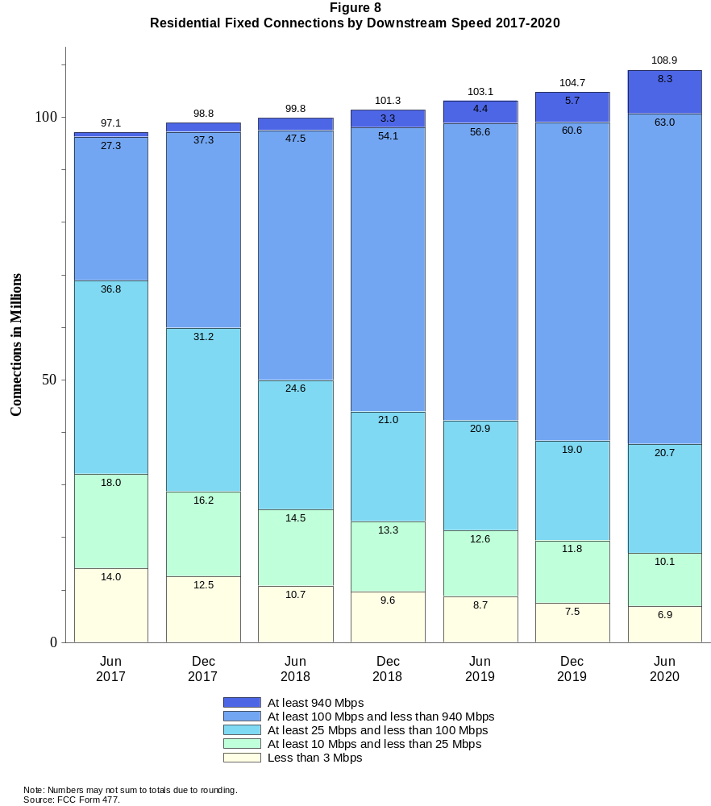

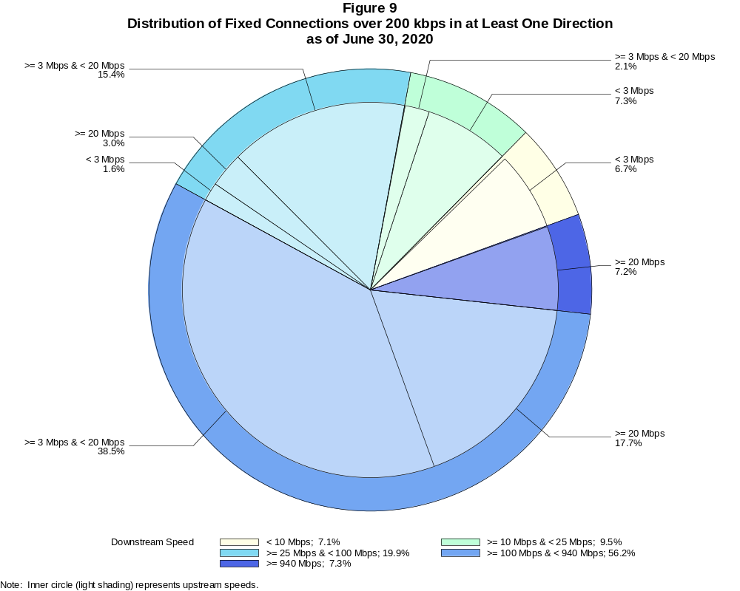

Fixed Connections over 200 kbps in at Least One Direction (in thousands)

 | Downstream Speed
Upstream Speed | Less than 10 Mbps | At least 10 Mbps  and less than 25 Mbps | At least 25 Mbps  and less than 100 Mbps | At least 100 Mbps  and less than 940 Mbps | At least 940 Mbps | Total
Less than 3 Mbps | 7,992 | 8,657 | 1,876 | 11 | # | 18,536
At least 3 Mbps & Less than 20 Mbps | 377 | 2,480 | 18,219 | 45,590 | 89 | 66,755
At least 20 Mbps | 2 | 71 | 3,531 | 20,997 | 8,557 | 33,158
Total | 8,371 | 11,207 | 23,626 | 66,598 | 8,647 | 118,449

Percentages

Less than 3 Mbps | 6.7 | 7.3 | 1.6 | 0.0 | 0.0 | 15.6
At least 3 Mbps & Less than 20 Mbps | 0.3 | 2.1 | 15.4 | 38.5 | 0.1 | 56.4
At least 20 Mbps | 0.0 | 0.1 | 3.0 | 17.7 | 7.2 | 28.0
Total | 7.1 | 9.5 | 19.9 | 56.2 | 7.3 | 100.0

Note: Numbers may not sum to totals due to rounding. # = Rounds to zero.
Source: FCC Form 477.

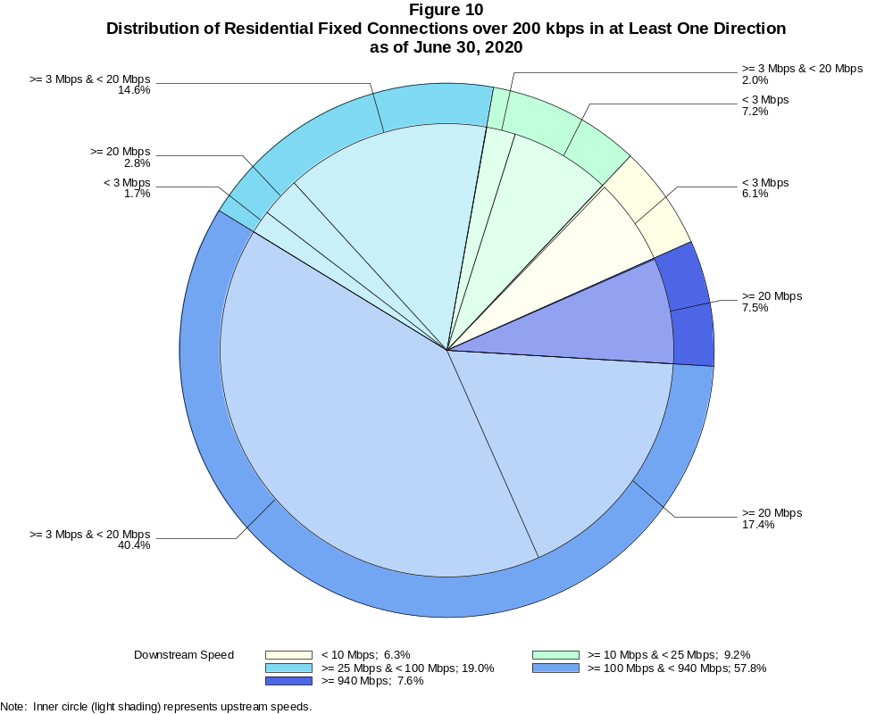

Residential Fixed Connections over 200 kbps in at Least One Direction (in thousands)

 | Downstream Speed
Upstream Speed | Less than 10 Mbps | At least 10 Mbps  and less than 25 Mbps | At least 25 Mbps  and less than 100 Mbps | At least 100 Mbps  and less than 940 Mbps | At least 940 Mbps | Total
Less than 3 Mbps | 6,653 | 7,811 | 1,803 | 10 | # | 16,276
At least 3 Mbps & Less than 20 Mbps | 204 | 2,224 | 15,864 | 43,985 | 89 | 62,365
At least 20 Mbps | 2 | 33 | 3,068 | 18,963 | 8,201 | 30,267
Total | 6,858 | 10,067 | 20,735 | 62,958 | 8,290 | 108,909

Percentages

Less than 3 Mbps | 6.1 | 7.2 | 1.7 | 0.0 | 0.0 | 14.9
At least 3 Mbps & Less than 20 Mbps | 0.2 | 2.0 | 14.6 | 40.4 | 0.1 | 57.3
At least 20 Mbps | 0.0 | 0.0 | 2.8 | 17.4 | 7.5 | 27.8
Total | 6.3 | 9.2 | 19.0 | 57.8 | 7.6 | 100.0

Note: Numbers may not sum to totals due to rounding. # = Rounds to zero.
Source: FCC Form 477.

Figure 11
Connections over 200 kbps in at Least One Direction by Technology 2016-2020
(in thousands)

 | 2016 |  | 2017 |  | 2018 |  | 2019 |  | 2020
Technology | Jun | Dec | Jun | Dec | Jun | Dec | Jun | Dec | Jun
Total | 395,496 | 404,849 | 408,692 | 420,838 | 428,864 | 451,062 | 459,327 | 466,302 | 480,185
Total Fixed | 103,980 | 105,593 | 106,130 | 108,065 | 109,087 | 110,784 | 112,725 | 114,291 | 118,449
aDSL | 27,488 | 26,527 | 25,505 | 24,193 | 23,074 | 22,377 | 21,163 | 20,214 | 19,639
sDSL | 55 | 42 | 44 | 28 | 28 | 20 | 17 | 16 | 19
Other Wireline¹ | 622 | 599 | 619 | 581 | 558 | 557 | 501 | 525 | 516
Cable Modem | 61,456 | 63,325 | 64,060 | 66,196 | 67,165 | 68,882 | 70,750 | 72,516 | 75,986
FTTP² | 11,087 | 11,986 | 12,831 | 13,890 | 14,889 | 15,492 | 16,748 | 17,376 | 18,443
Satellite | 2,079 | 1,864 | 1,826 | 1,872 | 1,939 | 1,971 | 1,984 | 1,975 | 1,993
Fixed Wireless | 1,193 | 1,250 | 1,245 | 1,306 | 1,434 | 1,485 | 1,561 | 1,669 | 1,853
Mobile Wireless | 291,516 | 299,256 | 302,562 | 312,773 | 319,776 | 340,278 | 346,603 | 352,012 | 361,737

¹ Power Line and Other are summarized with Other Wireline for confidentiality reasons. See Technical Notes at the end of the report for a description of
FCC Form 477 technology categories and other reporting requirements.
² Fiber to the premises.
Note: Some previously-published data may have been revised. Numbers may not sum to totals due to rounding.
Source: FCC Form 477.

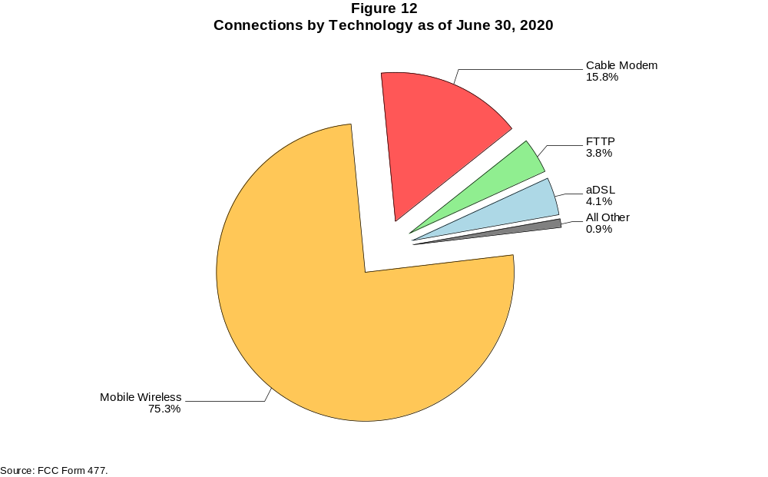

Figure 13
Residential Connections over 200 kbps in at Least One Direction by Technology 2016-2020
(in thousands)

 | 2016 |  | 2017 |  | 2018 |  | 2019 |  | 2020
Technology | Jun | Dec | Jun | Dec | Jun | Dec | Jun | Dec | Jun
Total | 330,987 | 337,978 | 341,094 | 351,966 | 358,867 | 378,286 | 383,605 | 388,344 | 403,212
Total Fixed | 95,001 | 96,607 | 97,071 | 98,845 | 99,758 | 101,348 | 103,118 | 104,703 | 108,909
aDSL | 24,486 | 23,691 | 22,774 | 21,653 | 20,671 | 20,126 | 18,976 | 18,159 | 17,647
sDSL | 10 | 8 | 12 | 9 | 9 | 4 | 4 | 5 | 7
Other Wireline¹ | 51 | 32 | 74 | 67 | 74 | 76 | 62 | 74 | 64
Cable Modem | 57,358 | 59,145 | 59,687 | 61,567 | 62,320 | 63,813 | 65,457 | 67,141 | 70,710
FTTP² | 10,140 | 10,956 | 11,776 | 12,702 | 13,663 | 14,205 | 15,410 | 16,011 | 16,971
Satellite | 1,897 | 1,676 | 1,637 | 1,688 | 1,751 | 1,787 | 1,805 | 1,795 | 1,815
Fixed Wireless | 1,059 | 1,100 | 1,112 | 1,158 | 1,270 | 1,338 | 1,405 | 1,520 | 1,694
Mobile Wireless | 235,985 | 241,371 | 244,022 | 253,121 | 259,109 | 276,938 | 280,486 | 283,641 | 294,303

¹ Power Line and Other are summarized with Other Wireline for confidentiality reasons. See Technical Notes at the end of the report for a description of
FCC Form 477 technology categories and other reporting requirements.
² Fiber to the premises.
Note: Some previously-published data may have been revised. Numbers may not sum to totals due to rounding.
Source: FCC Form 477.

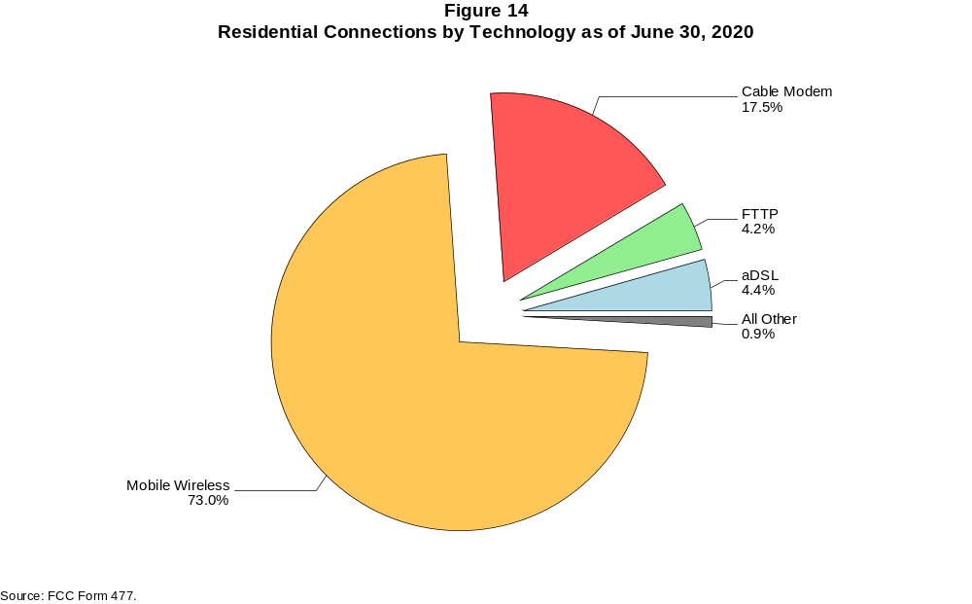

Figure 15
Fixed Connections at Least 10 Mbps Downstream and 1 Mbps Upstream by Technology 2016-2020
(in thousands)

 | 2016 |  | 2017 |  | 2018 |  | 2019 |  | 2020
Technology | Jun | Dec | Jun | Dec | Jun | Dec | Jun | Dec | Jun
Total | 80,397 | 84,038 | 86,886 | 90,609 | 94,071 | 97,302 | 100,464 | 103,595 | 109,159
aDSL | 10,349 | 10,810 | 11,321 | 11,598 | 11,822 | 12,038 | 11,829 | 11,704 | 12,421
sDSL | 8 | 10 | 14 | 9 | 11 | 6 | 5 | 5 | 8
Other Wireline¹ | 203 | 209 | 246 | 262 | 271 | 292 | 261 | 301 | 307
Cable Modem | 57,951 | 60,349 | 61,704 | 63,978 | 65,808 | 67,716 | 69,704 | 71,934 | 75,391
FTTP² | 10,088 | 10,935 | 11,811 | 12,869 | 13,898 | 14,815 | 16,078 | 16,854 | 17,993
Satellite | 1,467 | 1,342 | 1,373 | 1,402 | 1,595 | 1,677 | 1,726 | 1,737 | 1,778
Fixed Wireless | 330 | 383 | 418 | 491 | 666 | 759 | 861 | 1,059 | 1,263

¹ Power Line and Other are summarized with Other Wireline for confidentiality reasons. See Technical Notes at the end of the report for a description of
FCC Form 477 technology categories and other reporting requirements.
² Fiber to the premises.
# = Rounds to zero.
Note: Some previously-published data may have been revised. Numbers may not sum to totals due to rounding.
Source: FCC Form 477.

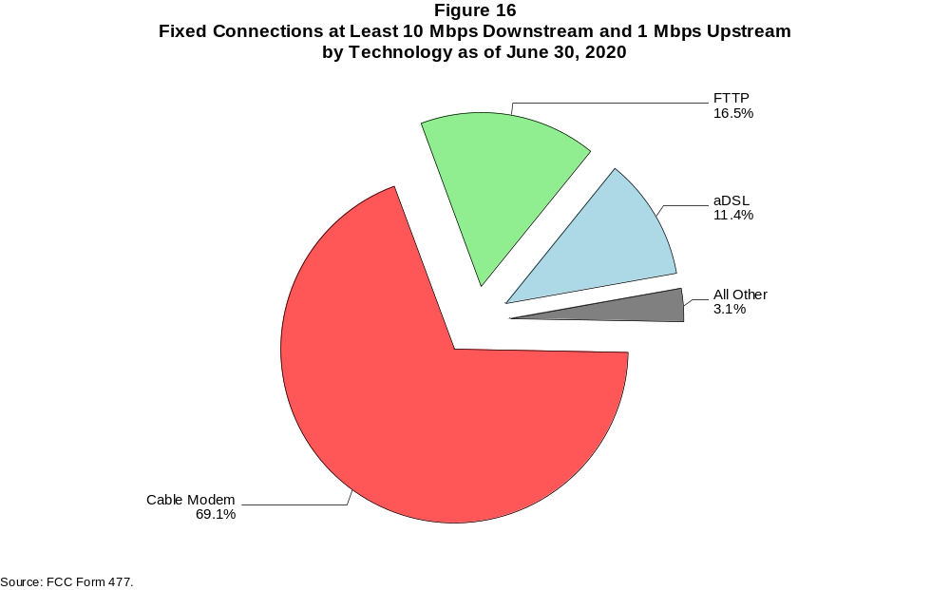

Figure 17
Residential Fixed Connections at Least 10 Mbps Downstream and 1 Mbps Upstream by Technology 2016-2020
(in thousands)

 | 2016 |  | 2017 |  | 2018 |  | 2019 |  | 2020
Technology | Jun | Dec | Jun | Dec | Jun | Dec | Jun | Dec | Jun
Total | 74,841 | 78,201 | 80,671 | 84,163 | 86,973 | 89,873 | 92,698 | 95,649 | 101,201
aDSL | 9,526 | 9,963 | 10,415 | 10,657 | 10,862 | 11,073 | 10,812 | 10,682 | 11,374
sDSL | 2 | 2 | 6 | 5 | 6 | 2 | 1 | 2 | 4
Other Wireline¹ | 47 | 30 | 71 | 64 | 65 | 68 | 58 | 70 | 61
Cable Modem | 54,274 | 56,538 | 57,617 | 59,864 | 61,142 | 62,810 | 64,556 | 66,691 | 70,299
FTTP² | 9,248 | 10,004 | 10,835 | 11,762 | 12,741 | 13,589 | 14,800 | 15,536 | 16,566
Satellite | 1,460 | 1,333 | 1,362 | 1,387 | 1,575 | 1,655 | 1,702 | 1,708 | 1,745
Fixed Wireless | 283 | 332 | 365 | 425 | 582 | 676 | 768 | 960 | 1,151

¹ Power Line and Other are summarized with Other Wireline for confidentiality reasons. See Technical Notes at the end of the report for a description of
FCC Form 477 technology categories and other reporting requirements.
² Fiber to the premises.
# = Rounds to zero.
Note: Some previously-published data may have been revised. Numbers may not sum to totals due to rounding.
Source: FCC Form 477.

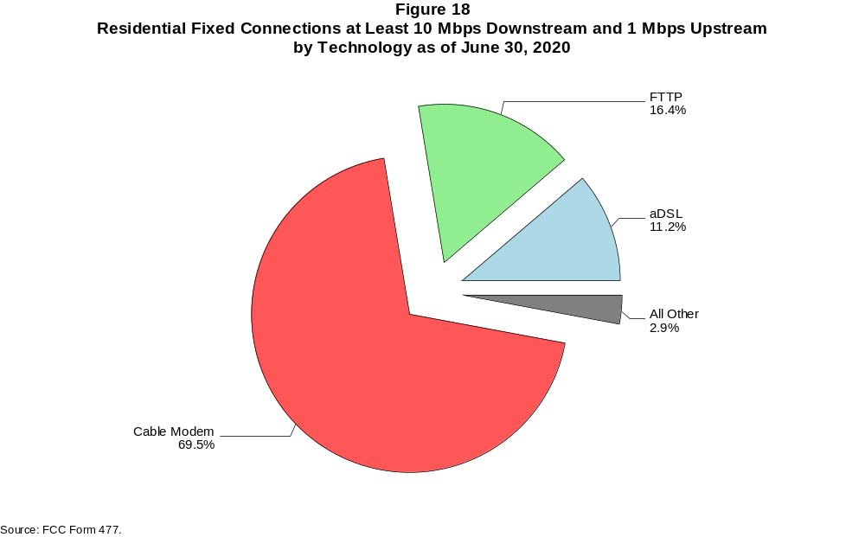

Figure 19
Fixed Connections at Least 25 Mbps Downstream and 3 Mbps Upstream by Technology 2016-2020
(in thousands)

 | 2016 |  | 2017 |  | 2018 |  | 2019 |  | 2020
Technology | Jun | Dec | Jun | Dec | Jun | Dec | Jun | Dec | Jun
Total | 58,765 | 62,933 | 68,280 | 73,875 | 78,952 | 82,965 | 86,744 | 90,471 | 96,984
aDSL | 1,239 | 1,476 | 2,530 | 3,586 | 4,298 | 4,988 | 5,233 | 5,523 | 5,910
sDSL | * | * | * | * | * | * | * | * | *
Other Wireline¹ | 155 | 166 | 203 | 219 | 203 | 228 | 220 | 263 | 273
Cable Modem | 48,696 | 51,740 | 54,829 | 57,870 | 60,859 | 62,880 | 64,938 | 67,171 | 71,856
FTTP² | 8,587 | 9,422 | 10,344 | 11,489 | 12,568 | 13,605 | 14,902 | 15,866 | 17,076
Satellite | * | * | * | * | * | * | * | * | *
Fixed Wireless | 72 | 92 | 120 | 143 | 224 | 267 | 325 | 449 | 571

¹ Power Line and Other are summarized with Other Wireline for confidentiality reasons. See Technical Notes at the end of the report for a description of
FCC Form 477 technology categories and other reporting requirements.
² Fiber to the premises.
* = Data withheld for confidentiality reasons.
# = Rounds to zero.
Note: Some previously-published data may have been revised. Numbers may not sum to totals due to rounding.
Source: FCC Form 477.

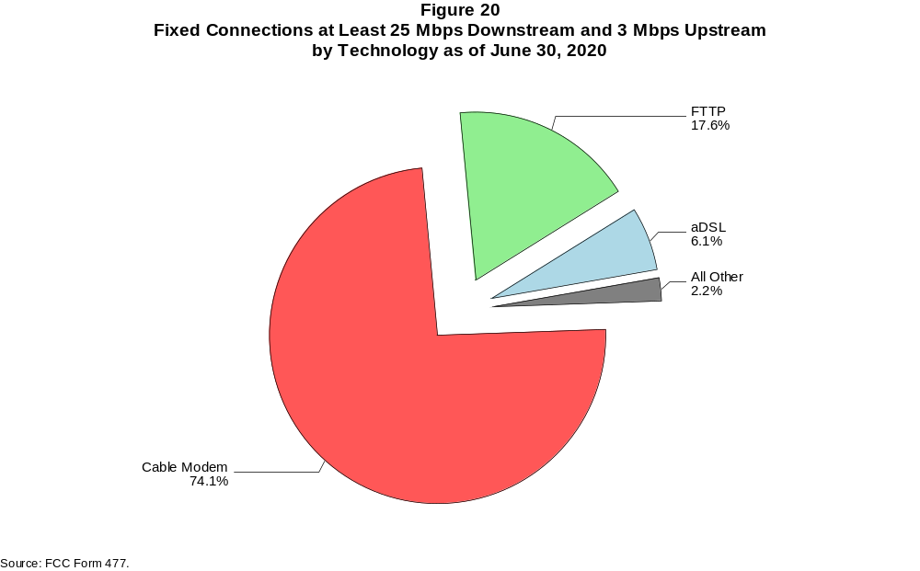

Figure 21
Residential Fixed Connections at Least 25 Mbps Downstream and 3 Mbps Upstream by Technology 2016-2020
(in thousands)

 | 2016 |  | 2017 |  | 2018 |  | 2019 |  | 2020
Technology | Jun | Dec | Jun | Dec | Jun | Dec | Jun | Dec | Jun
Total | 55,729 | 59,518 | 64,520 | 69,447 | 73,288 | 76,873 | 80,256 | 83,725 | 90,170
aDSL | 1,173 | 1,408 | 2,418 | 3,410 | 4,068 | 4,712 | 4,911 | 5,168 | 5,538
sDSL | * | * | * | * | * | * | * | * | *
Other Wireline¹ | 41 | 27 | 67 | 59 | 54 | 61 | 53 | 64 | 56
Cable Modem | 46,527 | 49,300 | 52,154 | 54,748 | 56,620 | 58,342 | 60,125 | 62,231 | 67,017
FTTP² | 7,916 | 8,674 | 9,532 | 10,553 | 11,570 | 12,546 | 13,780 | 14,690 | 15,781
Satellite | * | * | * | * | * | * | * | * | *
Fixed Wireless | 57 | 75 | 101 | 119 | 193 | 234 | 283 | 400 | 512

¹ Power Line and Other are summarized with Other Wireline for confidentiality reasons. See Technical Notes at the end of the report for a description of
FCC Form 477 technology categories and other reporting requirements.
² Fiber to the premises.
* = Data withheld for confidentiality reasons.
# = Rounds to zero.
Note: Some previously-published data may have been revised. Numbers may not sum to totals due to rounding.
Source: FCC Form 477.

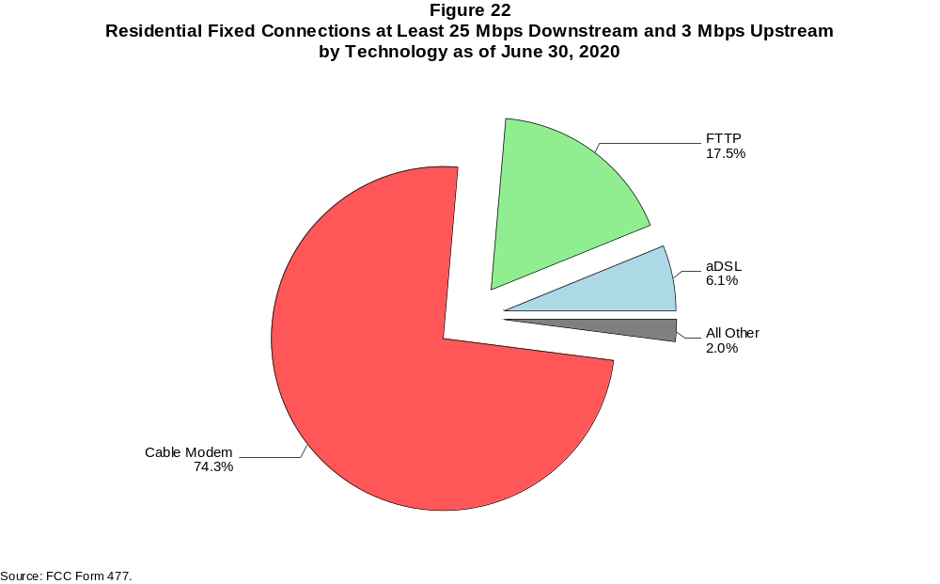

Figure 23
Fixed Connections at Least 100 Mbps Downstream and 20 Mbps Upstream by Technology 2016-2020
(in thousands)

 | 2016 |  | 2017 |  | 2018 |  | 2019 |  | 2020
Technology | Jun | Dec | Jun | Dec | Jun | Dec | Jun | Dec | Jun
Total | 6,866 | 7,968 | 9,676 | 12,148 | 14,619 | 18,750 | 22,217 | 25,603 | 29,554
aDSL | 1 | 2 | 16 | 47 | 59 | 207 | 387 | 569 | 658
sDSL | # | 1 | 1 | 1 | 1 | 1 | # | * | *
Other Wireline¹ | 117 | 140 | 174 | 192 | 174 | 196 | 178 | 211 | 213
Cable Modem | 5,259 | 5,356 | 6,055 | 7,149 | 8,352 | 9,466 | 11,426 | 13,088 | 15,496
FTTP² | 1,470 | 2,438 | 3,403 | 4,729 | 5,976 | 8,815 | 10,146 | 11,634 | 13,071
Satellite | 0 | 0 | 0 | 0 | 0 | 0 | 0 | * | *
Fixed Wireless | 20 | 31 | 28 | 30 | 56 | 65 | 79 | 101 | 116

¹ Power Line and Other are summarized with Other Wireline for confidentiality reasons. See Technical Notes at the end of the report for a description of
FCC Form 477 technology categories and other reporting requirements.
² Fiber to the premises.
* = Data withheld for confidentiality reasons.
# = Rounds to zero.
Note: Some previously-published data may have been revised. Numbers may not sum to totals due to rounding.
Source: FCC Form 477.

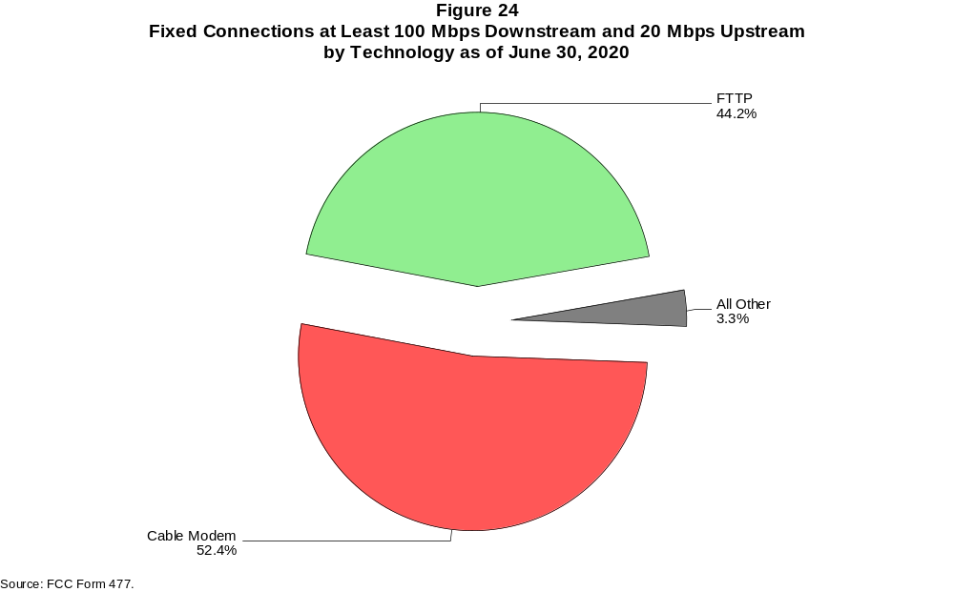

Figure 25
Residential Fixed Connections at Least 100 Mbps Downstream and 20 Mbps Upstream by Technology 2016-2020
(in thousands)

 | 2016 |  | 2017 |  | 2018 |  | 2019 |  | 2020
Technology | Jun | Dec | Jun | Dec | Jun | Dec | Jun | Dec | Jun
Total | 6,316 | 7,291 | 8,879 | 11,030 | 13,171 | 17,101 | 20,322 | 23,469 | 27,164
aDSL | 1 | 2 | 15 | 42 | 53 | 194 | 344 | 512 | 594
sDSL | # | # | # | # | # | # | # | * | *
Other Wireline¹ | 28 | 24 | 61 | 53 | 46 | 47 | 27 | 36 | 27
Cable Modem | 5,020 | 5,071 | 5,695 | 6,591 | 7,491 | 8,512 | 10,312 | 11,883 | 14,157
FTTP² | 1,253 | 2,170 | 3,089 | 4,324 | 5,534 | 8,292 | 9,574 | 10,952 | 12,288
Satellite | 0 | 0 | 0 | 0 | 0 | 0 | 0 | * | *
Fixed Wireless | 14 | 24 | 20 | 20 | 47 | 56 | 65 | 86 | 98

¹ Power Line and Other are summarized with Other Wireline for confidentiality reasons. See Technical Notes at the end of the report for a description of
FCC Form 477 technology categories and other reporting requirements.
² Fiber to the premises.
* = Data withheld for confidentiality reasons.
# = Rounds to zero.
Note: Some previously-published data may have been revised. Numbers may not sum to totals due to rounding.
Source: FCC Form 477.

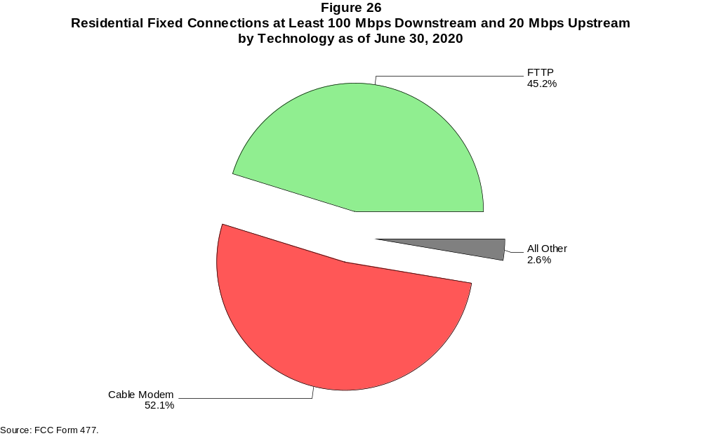

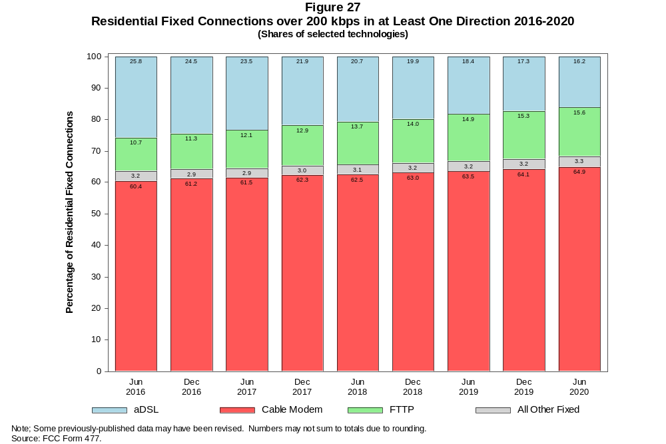

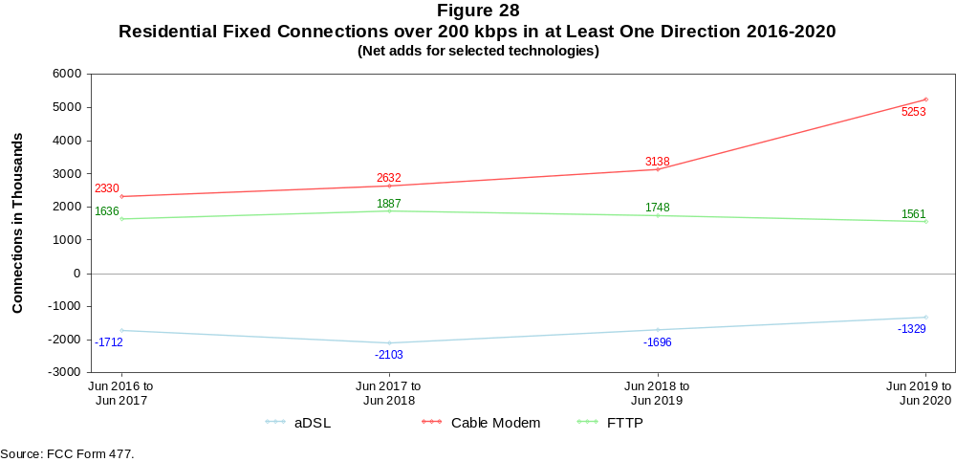

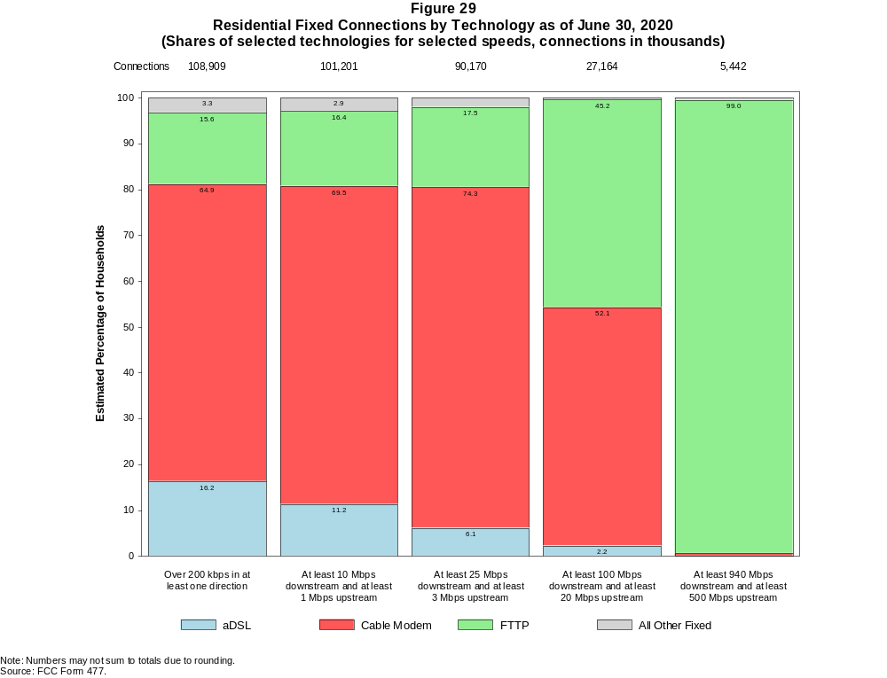

Figure 30
Fixed Connections by Downstream Speed Tier and Technology as of June 30, 2020
(in thousands)

 | Downstream Speed
Technology | Less than  4 Mbps | At least 4 Mbps  and less than  10 Mbps | At least 10 Mbps  and less than  25 Mbps | At least 25 Mbps  and less than  100 Mbps | At least 100 Mbps  and less than  940 Mbps | At least 940 Mbps | Total
aDSL | 2,673 | 3,654 | 6,707 | 5,746 | 858 | 1 | 19,639
sDSL | * | * | * | * | * | # | 19
Other Wireline¹ | 177 | 33 | 33 | 37 | 217 | 20 | 516
Cable Modem | 307 | 276 | 2,436 | 12,321 | 57,753 | 2,892 | 75,986
FTTP | 140 | 295 | 864 | 3,780 | 7,661 | 5,703 | 18,443
Satellite | * | * | * | * | * | 0 | 1,993
Fixed Wireless | 215 | 375 | 680 | 459 | 95 | 30 | 1,853
Total | 3,685 | 4,686 | 11,207 | 23,626 | 66,598 | 8,647 | 118,449

Percentages

aDSL | 2.3 | 3.1 | 5.7 | 4.9 | 0.7 | 0.0 | 16.6
sDSL | * | * | * | * | * | 0.0 | 0.0
Other Wireline¹ | 0.1 | 0.0 | 0.0 | 0.0 | 0.2 | 0.0 | 0.4
Cable Modem | 0.3 | 0.2 | 2.1 | 10.4 | 48.8 | 2.4 | 64.2
FTTP | 0.1 | 0.2 | 0.7 | 3.2 | 6.5 | 4.8 | 15.6
Satellite | * | * | * | * | * | 0.0 | 1.7
Fixed Wireless | 0.2 | 0.3 | 0.6 | 0.4 | 0.1 | 0.0 | 1.6
Total | 3.1 | 4.0 | 9.5 | 19.9 | 56.2 | 7.3 | 100.0

¹ Power Line and Other are summarized with Other Wireline for confidentiality reasons. See Technical Notes at the end of the report for a description of FCC Form 477 technology categories
and other reporting requirements.
# = Rounds to Zero.
* = Data withheld for confidentiality reasons.
Note: Numbers may not sum to totals due to rounding.
Source: FCC Form 477.

Figure 31
Residential Fixed Connections by Downstream Speed Tier and Technology as of June 30, 2020
(in thousands)

 | Downstream Speed
Technology | Less than  4 Mbps | At least 4 Mbps  and less than  10 Mbps | At least 10 Mbps  and less than  25 Mbps | At least 25 Mbps  and less than  100 Mbps | At least 100 Mbps  and less than  940 Mbps | At least 940 Mbps | Total
aDSL | 2,237 | 3,210 | 6,019 | 5,397 | * | * | 17,647
sDSL | * | * | * | * | * | * | 7
Other Wireline¹ | 1 | 1 | 5 | 5 | 35 | 16 | 64
Cable Modem | 264 | 138 | 2,194 | 10,355 | 54,991 | 2,769 | 70,710
FTTP | 120 | 271 | 738 | 3,309 | 7,055 | 5,479 | 16,971
Satellite | * | * | * | * | * | 0 | 1,815
Fixed Wireless | 192 | 351 | 628 | 417 | 79 | 26 | 1,694
Total | 2,837 | 4,021 | 10,067 | 20,735 | 62,958 | 8,290 | 108,909

Percentages

aDSL | 2.1 | 2.9 | 5.5 | 5.0 | * | * | 16.2
sDSL | * | * | * | * | * | * | 0.0
Other Wireline¹ | 0.0 | 0.0 | 0.0 | 0.0 | 0.0 | 0.0 | 0.1
Cable Modem | 0.2 | 0.1 | 2.0 | 9.5 | 50.5 | 2.5 | 64.9
FTTP | 0.1 | 0.2 | 0.7 | 3.0 | 6.5 | 5.0 | 15.6
Satellite | * | * | * | * | * | 0.0 | 1.7
Fixed Wireless | 0.2 | 0.3 | 0.6 | 0.4 | 0.1 | 0.0 | 1.6
Total | 2.6 | 3.7 | 9.2 | 19.0 | 57.8 | 7.6 | 100.0

¹ Power Line and Other are summarized with Other Wireline for confidentiality reasons. See Technical Notes at the end of the report for a description of FCC Form 477 technology categories
and other reporting requirements.
# = Rounds to Zero.
* = Data withheld for confidentiality reasons.
Note: Numbers may not sum to totals due to rounding.
Source: FCC Form 477.

Figure 32
Nationwide Number of Providers of Connections over 200 kbps in at Least One Direction
by Technology 2016-2020

 | 2016 |  | 2017 |  | 2018 |  | 2019 |  | 2020
Technology | Jun | Dec | Jun | Dec | Jun | Dec | Jun | Dec | Jun
aDSL | 769 | 774 | 768 | 743 | 738 | 721 | 715 | 691 | 677
sDSL | 171 | 160 | 161 | 150 | 136 | 127 | 123 | 121 | 118
Other Wireline¹ | 244 | 236 | 243 | 235 | 249 | 243 | 222 | 211 | 215
Cable Modem | 388 | 385 | 384 | 383 | 372 | 381 | 381 | 373 | 365
FTTP | 1,017 | 1,066 | 1,103 | 1,147 | 1,183 | 1,269 | 1,309 | 1,330 | 1,377
Satellite | 6 | 6 | 5 | 6 | 6 | 6 | 6 | 5 | 5
Fixed Wireless | 1,027 | 1,071 | 1,095 | 1,160 | 1,188 | 1,239 | 1,248 | 1,280 | 1,312
Mobile Wireless | 99 | 98 | 98 | 83 | 73 | 71 | 70 | 67 | 64
Total | 1,957 | 2,000 | 2,030 | 2,090 | 2,129 | 2,215 | 2,223 | 2,247 | 2,279

¹ Power Line and Other are summarized with Other Wireline for confidentiality reasons.
Note: Multiple FCC Form 477 filers within a holding company structure count as one provider. Some previously-published data may have been revised.
Source: FCC Form 477.

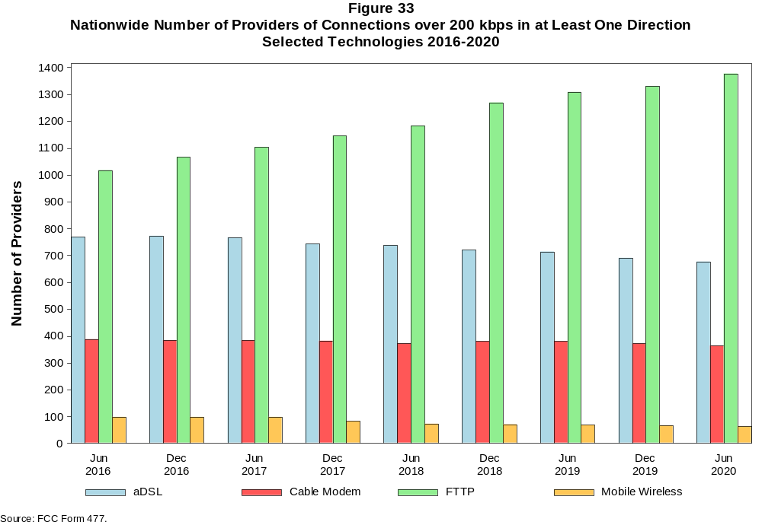

Figure 34
Residential Fixed Connections and Households by State as of June 30, 2020
(Connections and households, in thousands)

 |  | At least 200 kbps in  at least One Direction |  | At least 10 Mbps Down  and 1 Mbps Up |  | At least 25 Mbps Down  and 3 Mbps Up |  | At least 100 Mbps Down  and 20 Mbps Up |  | At least 940 Mbps Down  and 500 Mbps Up
State | Households | Connections | Subscribership  Ratio | Connections | Subscribership  Ratio | Connections | Subscribership  Ratio | Connections | Subscribership  Ratio | Connections | Subscribership  Ratio
Alabama | 1,889 | 1,490 | 0.79 | 1,312 | 0.69 | 1,096 | 0.58 | 298 | 0.16 | 63 | 0.03
Alaska | 255 | 219 | 0.86 | 196 | 0.77 | 145 | 0.57 | 57 | 0.23 | 0 | 0.00
American Samoa | 10 | * | * | * | * | * | * | 0 | 0.00 | 0 | 0.00
Arizona | 2,643 | 2,348 | 0.89 | 2,198 | 0.83 | 1,866 | 0.71 | 459 | 0.17 | * | *
Arkansas | 1,170 | 865 | 0.74 | 730 | 0.62 | 579 | 0.49 | 182 | 0.16 | 25 | 0.02
California | 13,103 | 12,056 | 0.92 | 11,413 | 0.87 | 10,409 | 0.79 | 2,390 | 0.18 | 324 | 0.02
Colorado | 2,137 | 2,060 | 0.96 | 1,941 | 0.91 | 1,720 | 0.80 | 254 | 0.12 | 78 | 0.04
Connecticut | 1,385 | 1,276 | 0.92 | 1,213 | 0.88 | 1,055 | 0.76 | 319 | 0.23 | 3 | 0.00
Delaware | 371 | 372 | 1.00 | 362 | 0.98 | 357 | 0.96 | 106 | 0.29 | * | *
District of Columbia | 288 | 268 | 0.93 | 260 | 0.90 | 255 | 0.88 | 104 | 0.36 | * | *
Florida | 7,931 | 7,842 | 0.99 | 7,410 | 0.93 | 6,635 | 0.84 | 2,009 | 0.25 | 228 | 0.03
Georgia | 3,830 | 3,357 | 0.88 | 3,097 | 0.81 | 2,645 | 0.69 | 952 | 0.25 | 222 | 0.06
Guam | 42 | * | * | * | * | * | * | 0 | 0.00 | 0 | 0.00
Hawaii | 468 | 478 | 1.02 | * | * | * | * | * | * | * | *
Idaho | 649 | 555 | 0.86 | 482 | 0.74 | 346 | 0.53 | 100 | 0.15 | 12 | 0.02
Illinois | 4,884 | 4,107 | 0.84 | 3,816 | 0.78 | 3,201 | 0.66 | 939 | 0.19 | 69 | 0.01
Indiana | 2,603 | 2,153 | 0.83 | 1,932 | 0.74 | 1,603 | 0.62 | 507 | 0.19 | 62 | 0.02
Iowa | 1,274 | 1,040 | 0.82 | 910 | 0.71 | 751 | 0.59 | 221 | 0.17 | 16 | 0.01
Kansas | 1,142 | 958 | 0.84 | 862 | 0.75 | 721 | 0.63 | 251 | 0.22 | 82 | 0.07
Kentucky | 1,748 | 1,445 | 0.83 | 1,286 | 0.74 | 1,108 | 0.63 | 312 | 0.18 | 40 | 0.02
Louisiana | 1,752 | 1,403 | 0.80 | 1,270 | 0.72 | 1,074 | 0.61 | 338 | 0.19 | 44 | 0.03
Maine | 570 | 557 | 0.98 | 494 | 0.87 | 402 | 0.71 | 29 | 0.05 | 1 | 0.00
Maryland | 2,231 | 2,088 | 0.94 | 2,028 | 0.91 | 1,962 | 0.88 | 737 | 0.33 | * | *
Massachusetts | 2,647 | 2,494 | 0.94 | 2,418 | 0.91 | 2,380 | 0.90 | 584 | 0.22 | * | *
Michigan | 3,980 | 3,345 | 0.84 | 3,086 | 0.78 | 2,640 | 0.66 | 535 | 0.13 | 39 | 0.01
Minnesota | 2,208 | 1,921 | 0.87 | 1,746 | 0.79 | 1,521 | 0.69 | 221 | 0.10 | 33 | 0.02
Mississippi | 1,117 | 774 | 0.69 | 652 | 0.58 | 474 | 0.42 | 124 | 0.11 | 23 | 0.02
Missouri | 2,440 | 1,990 | 0.82 | 1,730 | 0.71 | 1,476 | 0.60 | 507 | 0.21 | 123 | 0.05
Montana | 436 | 374 | 0.86 | 324 | 0.74 | 263 | 0.60 | 34 | 0.08 | * | *
Nebraska | 767 | 649 | 0.85 | 598 | 0.78 | 506 | 0.66 | 155 | 0.20 | 24 | 0.03

Figure 34 - Continued
Residential Fixed Connections and Households by State as of June 30, 2020
(Connections and households, in thousands)

 |  | At least 200 kbps in  at least One Direction |  | At least 10 Mbps Down  and 1 Mbps Up |  | At least 25 Mbps Down  and 3 Mbps Up |  | At least 100 Mbps Down  and 20 Mbps Up |  | At least 940 Mbps Down  and 500 Mbps Up
State | Households | Connections | Subscribership  Ratio | Connections | Subscribership  Ratio | Connections | Subscribership  Ratio | Connections | Subscribership  Ratio | Connections | Subscribership  Ratio
Nevada | 1,130 | 1,028 | 0.91 | 967 | 0.86 | 866 | 0.77 | 233 | 0.21 | 21 | 0.02
New Hampshire | 539 | 539 | 1.00 | 508 | 0.94 | 470 | 0.87 | 61 | 0.11 | 1 | 0.00
New Jersey | 3,272 | 3,098 | 0.95 | 3,032 | 0.93 | 2,973 | 0.91 | 1,636 | 0.50 | * | *
New Mexico | 793 | 657 | 0.83 | 566 | 0.71 | 449 | 0.57 | 48 | 0.06 | 4 | 0.01
New York | 7,417 | 6,563 | 0.88 | 6,398 | 0.86 | 6,056 | 0.82 | 3,292 | 0.44 | * | *
North Carolina | 4,032 | 3,692 | 0.92 | 3,322 | 0.82 | 3,059 | 0.76 | 909 | 0.23 | 180 | 0.04
North Dakota | 321 | 289 | 0.90 | 278 | 0.87 | 257 | 0.80 | 63 | 0.20 | 3 | 0.01
Northern Mariana Isl | 16 | * | * | * | * | * | * | 0 | 0.00 | 0 | 0.00
Ohio | 4,717 | 4,028 | 0.85 | 3,700 | 0.78 | 3,212 | 0.68 | 640 | 0.14 | * | *
Oklahoma | 1,494 | 1,158 | 0.78 | 1,020 | 0.68 | 851 | 0.57 | 283 | 0.19 | 51 | 0.03
Oregon | 1,643 | 1,461 | 0.89 | 1,345 | 0.82 | 1,207 | 0.73 | 177 | 0.11 | 30 | 0.02
Pennsylvania | 5,107 | 4,444 | 0.87 | 4,124 | 0.81 | 3,958 | 0.78 | 1,107 | 0.22 | * | *
Puerto Rico | 1,206 | 639 | 0.53 | 545 | 0.45 | 317 | 0.26 | 70 | 0.06 | * | *
Rhode Island | 415 | 388 | 0.94 | 385 | 0.93 | 374 | 0.90 | 201 | 0.48 | * | *
South Carolina | 1,961 | 1,743 | 0.89 | 1,616 | 0.82 | 1,402 | 0.71 | 383 | 0.20 | 45 | 0.02
South Dakota | 348 | 300 | 0.86 | 290 | 0.83 | 266 | 0.76 | 37 | 0.11 | 1 | 0.00
Tennessee | 2,640 | 2,180 | 0.83 | 2,018 | 0.76 | 1,746 | 0.66 | 626 | 0.24 | 132 | 0.05
Texas | 9,906 | 8,714 | 0.88 | 8,197 | 0.83 | 7,297 | 0.74 | 2,689 | 0.27 | 590 | 0.06
Utah | 1,003 | 928 | 0.92 | 871 | 0.87 | 752 | 0.75 | 173 | 0.17 | 47 | 0.05
Vermont | 263 | 254 | 0.97 | 213 | 0.81 | 174 | 0.66 | 25 | 0.09 | * | *
Virgin Islands | 43 | * | * | * | * | * | * | * | * | 0 | 0.00
Virginia | 3,184 | 2,793 | 0.88 | 2,604 | 0.82 | 2,479 | 0.78 | 956 | 0.30 | * | *
Washington | 2,906 | 2,666 | 0.92 | 2,470 | 0.85 | 2,254 | 0.78 | 307 | 0.11 | 77 | 0.03
West Virginia | 734 | 536 | 0.73 | 429 | 0.58 | 364 | 0.50 | 106 | 0.14 | 2 | 0.00
Wisconsin | 2,378 | 2,041 | 0.86 | 1,835 | 0.77 | 1,564 | 0.66 | 230 | 0.10 | 27 | 0.01
Wyoming | 233 | 202 | 0.87 | 180 | 0.77 | 158 | 0.68 | 14 | 0.06 | 1 | 0.00
Total | 123,671 | 108,909 | 0.88 | 101,201 | 0.82 | 90,170 | 0.73 | 27,164 | 0.22 | 5,442 | 0.04

# = Rounds to Zero; * = Data withheld for confidentiality reasons.
Note: Numbers may not sum to totals due to rounding.
Sources: FCC Form 477 (Connections); 2016-2020 ACS 5-year estimates; Census 2010.

Figure 35
Connections by Type of End User by State as of June 30, 2020
(Connections over 200 kbps in at least one direction, in thousands)

 | Connections |  | Percentages
State | Residential | Business | Residential | Business | Total
Alabama | 5,553 | 1,298 | 81.1 | 18.9 | 6,851
Alaska | 860 | 137 | 86.3 | 13.7 | 997
American Samoa | * | * | * | * | *
Arizona | 8,486 | 1,396 | 85.9 | 14.1 | 9,883
Arkansas | 3,242 | 826 | 79.7 | 20.3 | 4,068
California | 50,000 | 9,811 | 83.6 | 16.4 | 59,811
Colorado | 6,991 | 1,379 | 83.5 | 16.5 | 8,370
Connecticut | 4,542 | 903 | 83.4 | 16.6 | 5,445
Delaware | 1,235 | 237 | 83.9 | 16.1 | 1,472
District of Columbia | 1,040 | 575 | 64.4 | 35.6 | 1,615
Florida | 27,334 | 4,666 | 85.4 | 14.6 | 32,000
Georgia | 14,346 | 1,108 | 92.8 | 7.2 | 15,454
Guam | 156 | 74 | 67.8 | 32.2 | 231
Hawaii | 1,815 | 316 | 85.2 | 14.8 | 2,131
Idaho | 1,981 | 376 | 84.1 | 15.9 | 2,357
Illinois | 15,579 | 3,177 | 83.1 | 16.9 | 18,756
Indiana | 7,597 | 1,497 | 83.5 | 16.5 | 9,094
Iowa | 3,526 | 773 | 82.0 | 18.0 | 4,299
Kansas | 3,390 | 669 | 83.5 | 16.5 | 4,059
Kentucky | 5,173 | 875 | 85.5 | 14.5 | 6,048
Louisiana | 5,632 | 961 | 85.4 | 14.6 | 6,594
Maine | 1,493 | 456 | 76.6 | 23.4 | 1,949
Maryland | 7,757 | 1,331 | 85.4 | 14.6 | 9,088
Massachusetts | 8,624 | 1,704 | 83.5 | 16.5 | 10,328
Michigan | 11,959 | 2,283 | 84.0 | 16.0 | 14,242
Minnesota | 6,618 | 1,373 | 82.8 | 17.2 | 7,991
Mississippi | 3,309 | 613 | 84.4 | 15.6 | 3,922
Missouri | 7,153 | 1,361 | 84.0 | 16.0 | 8,514
Montana | 1,146 | 320 | 78.2 | 21.8 | 1,465
Nebraska | 2,157 | 568 | 79.2 | 20.8 | 2,725
Nevada | 3,877 | 552 | 87.5 | 12.5 | 4,428
New Hampshire | 1,606 | 393 | 80.3 | 19.7 | 1,999
New Jersey | 11,742 | 2,109 | 84.8 | 15.2 | 13,852
New Mexico | 2,462 | 417 | 85.5 | 14.5 | 2,879
New York | 24,969 | 5,119 | 83.0 | 17.0 | 30,088
North Carolina | 11,989 | 2,680 | 81.7 | 18.3 | 14,669
North Dakota | 879 | 231 | 79.2 | 20.8 | 1,110
Northern Mariana Isl | * | * | * | * | *
Ohio | 14,031 | 2,933 | 82.7 | 17.3 | 16,965
Oklahoma | 4,586 | 797 | 85.2 | 14.8 | 5,383
Oregon | 5,016 | 1,005 | 83.3 | 16.7 | 6,021
Pennsylvania | 15,135 | 3,215 | 82.5 | 17.5 | 18,350
Puerto Rico | 3,412 | 310 | 91.7 | 8.3 | 3,722
Rhode Island | 1,344 | 271 | 83.2 | 16.8 | 1,615
South Carolina | 5,765 | 1,242 | 82.3 | 17.7 | 7,007
South Dakota | 945 | 256 | 78.7 | 21.3 | 1,200
Tennessee | 7,848 | 1,743 | 81.8 | 18.2 | 9,591
Texas | 36,075 | 5,784 | 86.2 | 13.8 | 41,859
Utah | 3,466 | 684 | 83.5 | 16.5 | 4,150
Vermont | 697 | 228 | 75.4 | 24.6 | 925
Virgin Islands | 119 | 12 | 91.1 | 8.9 | 130
Virginia | 10,047 | 2,232 | 81.8 | 18.2 | 12,280
Washington | 9,280 | 1,797 | 83.8 | 16.2 | 11,077
West Virginia | 1,909 | 334 | 85.1 | 14.9 | 2,244
Wisconsin | 6,571 | 1,358 | 82.9 | 17.1 | 7,930
Wyoming | 661 | 172 | 79.4 | 20.6 | 833
Total | 403,212 | 76,974 | 84.0 | 16.0 | 480,185

# = Rounds to Zero.
* = Data withheld for confidentiality reasons.
Note: Numbers may not sum to totals due to rounding.
Source: FCC Form 477.

Figure 36
Connections by Technology by State as of June 30, 2020
(Connections over 200 kbps in at least one direction, in thousands)

State | ADSL | SDSL | Other  Wireline¹ | Cable  Modem | Fiber | Satellite | Fixed  Wireless | Mobile  Wireless | Total
Alabama | 406 | * | 4 | 897 | 237 | * | 10 | 5,231 | 6,851
Alaska | 76 | # | 2 | * | 12 | * | 13 | 742 | 997
American Samoa | 0 | 0 | 0 | * | * | 0 | * | * | *
Arizona | 596 | * | 12 | 1,668 | 147 | * | 55 | 7,365 | 9,883
Arkansas | 324 | # | * | 450 | 105 | * | 10 | 3,123 | 4,068
California | 2,332 | 2 | * | 9,023 | 1,424 | * | 173 | 46,645 | 59,811
Colorado | * | # | 18 | 1,479 | 182 | * | 86 | 6,140 | 8,370
Connecticut | * | * | 2 | 1,109 | 36 | * | # | * | 5,445
Delaware | * | * | 2 | 264 | * | * | * | * | 1,472
District of Columbia | * | * | 6 | * | * | * | * | * | 1,615
Florida | 1,210 | * | 24 | 5,991 | 1,200 | * | 24 | 23,466 | 32,000
Georgia | 814 | * | 10 | 2,131 | 622 | * | 11 | 11,791 | 15,454
Guam | * | 0 | 0 | * | * | 0 | 0 | 185 | 231
Hawaii | * | * | 1 | * | 70 | * | 1 | 1,602 | 2,131
Idaho | 217 | * | 3 | 264 | 43 | * | 58 | 1,755 | 2,357
Illinois | 941 | # | * | 3,072 | 307 | * | 88 | 14,288 | 18,756
Indiana | 512 | * | 3 | 1,339 | 362 | * | 56 | * | 9,094
Iowa | 286 | 1 | * | 518 | 232 | * | 61 | 3,169 | 4,299
Kansas | 201 | # | * | 530 | 240 | * | 49 | 3,017 | 4,059
Kentucky | 350 | * | 3 | 884 | 265 | * | 24 | 4,483 | 6,048
Louisiana | 366 | * | 4 | 906 | 180 | * | 14 | 5,063 | 6,594
Maine | 112 | 1 | * | 460 | 22 | * | 9 | 1,332 | 1,949
Maryland | * | # | 16 | 1,279 | * | * | 6 | 6,831 | 9,088
Massachusetts | * | # | 17 | 2,055 | * | * | 15 | * | 10,328
Michigan | 678 | 1 | * | 2,625 | 158 | * | 53 | 10,634 | 14,242
Minnesota | 469 | 1 | * | 1,274 | 251 | * | 45 | 5,915 | 7,991
Mississippi | 317 | * | 1 | 383 | 68 | * | 13 | 3,070 | 3,922
Missouri | 560 | * | 6 | 1,092 | 369 | * | 51 | 6,360 | 8,514
Montana | 96 | # | * | 235 | 37 | * | 32 | 1,048 | 1,465
Nebraska | 135 | # | * | 403 | 122 | * | 39 | 2,016 | 2,725

Figure 36 - Continued
Connections by Technology by State as of June 30, 2020
(Connections over 200 kbps in at least one direction, in thousands)

State | ADSL | SDSL | Other  Wireline¹ | Cable  Modem | Fiber | Satellite | Fixed  Wireless | Mobile  Wireless | Total
Nevada | 172 | # | 5 | * | 86 | * | 33 | 3,314 | 4,428
New Hampshire | 63 | # | * | 486 | 39 | * | 2 | 1,400 | 1,999
New Jersey | 96 | * | 24 | 2,191 | * | * | 1 | * | 13,852
New Mexico | 234 | * | 4 | 382 | 45 | * | 30 | 2,166 | 2,879
New York | 251 | * | 36 | 5,077 | 1,786 | * | 9 | 22,879 | 30,088
North Carolina | 671 | * | 8 | 2,671 | 542 | * | 16 | 10,685 | 14,669
North Dakota | 32 | * | 1 | 183 | 102 | * | 4 | 785 | 1,110
Northern Mariana Isl | * | 0 | 0 | * | * | 0 | 0 | * | *
Ohio | 841 | * | 10 | 2,969 | 397 | * | 60 | * | 16,965
Oklahoma | 314 | # | * | 644 | 193 | * | 61 | 4,116 | 5,383
Oregon | 222 | # | * | 1,088 | 201 | * | 37 | 4,429 | 6,021
Pennsylvania | 433 | # | * | 3,261 | 1,051 | * | 10 | 13,530 | 18,350
Puerto Rico | * | 0 | * | * | 50 | * | 34 | * | 3,722
Rhode Island | * | * | 2 | * | * | * | * | * | 1,615
South Carolina | 367 | * | 3 | 1,192 | 272 | * | 6 | 5,128 | 7,007
South Dakota | 39 | * | # | 198 | 74 | * | 12 | 870 | 1,200
Tennessee | 415 | # | * | 1,360 | 506 | * | 20 | 7,223 | 9,591
Texas | 1,707 | 1 | * | 5,340 | 1,879 | * | 287 | 32,399 | 41,859
Utah | 175 | * | 6 | 583 | 171 | * | 60 | 3,147 | 4,150
Vermont | 80 | * | 2 | 166 | 30 | * | 4 | 637 | 925
Virgin Islands | 0 | 0 | * | * | * | * | * | * | 130
Virginia | 232 | # | * | 1,682 | 996 | * | 25 | 9,237 | 12,280
Washington | 404 | # | * | 2,089 | 240 | * | 45 | 8,211 | 11,077
West Virginia | * | * | 1 | 367 | 18 | * | 6 | 1,658 | 2,244
Wisconsin | 517 | * | 3 | * | 196 | * | 51 | 5,718 | 7,930
Wyoming | 47 | * | 1 | 125 | 13 | * | 33 | 606 | 833
Total | 19,639 | 19 | 516 | 75,986 | 18,443 | 1,993 | 1,853 | 361,737 | 480,185

¹ PowerLine and Other are summarized with Other Wireline for confidentiality reasons. See Technical Notes at the end of the report for a description of FCC Form 477 technology categories and
other reporting requirements.
# = Rounds to Zero.
* = Data withheld for confidentiality reasons.
Note: Numbers may not sum to totals due to rounding.
Source: FCC Form 477.

Figure 37
Percentage of Fixed Connections by Downstream Speed by State as of June 30, 2020

 | Over 200 kbps Upstream and
State | % over 200 kbps  Downstream | % at least 10 Mbps  Downstream | % at least 25 Mbps  Downstream | % at least 100 Mbps  Downstream | % at least 940 Mbps  Downstream
Alabama | 99.8 | 89.3 | 76.5 | 55.8 | 4.9
Alaska | 99.7 | 87.4 | 65.3 | * | *
American Samoa | * | * | * | * | *
Arizona | 99.8 | 93.7 | 81.0 | 55.0 | 7.1
Arkansas | 99.8 | 86.9 | 68.5 | 37.7 | 4.8
California | 99.8 | 93.7 | 85.0 | 63.9 | 5.7
Colorado | 99.9 | 94.4 | 84.1 | 57.1 | 9.0
Connecticut | 99.7 | 94.0 | 83.0 | 70.7 | 3.6
Delaware | 100.0 | 96.6 | 95.1 | 76.5 | 16.2
District of Columbia | 99.9 | 94.4 | 92.3 | 79.8 | 18.4
Florida | 99.8 | 95.3 | 88.4 | 67.2 | 4.2
Georgia | 99.6 | 91.9 | 82.1 | 59.5 | 8.2
Guam | * | * | * | * | *
Hawaii | 100.0 | 94.9 | * | * | *
Idaho | 99.8 | 87.7 | 65.0 | 44.6 | 3.6
Illinois | 99.8 | 92.3 | 82.3 | 59.6 | 4.0
Indiana | 99.5 | 90.3 | 78.4 | 55.1 | 4.4
Iowa | 99.6 | 88.6 | 73.8 | 40.0 | 4.2
Kansas | 99.8 | 90.7 | 74.5 | 49.6 | 10.3
Kentucky | 99.6 | 89.1 | 77.2 | 56.4 | 3.4
Louisiana | 99.8 | 90.7 | 77.3 | 51.8 | 5.5
Maine | 99.2 | 87.2 | 72.7 | 61.1 | 1.7
Maryland | 99.9 | 95.9 | 92.9 | 74.5 | 18.2
Massachusetts | 100.0 | 95.9 | 94.2 | 82.0 | 13.0
Michigan | 99.6 | 91.8 | 82.5 | 61.5 | 2.5
Minnesota | 99.9 | 91.8 | 80.1 | 53.6 | 4.5
Mississippi | 99.6 | 84.5 | 64.6 | 37.2 | 3.9
Missouri | 99.7 | 89.4 | 75.2 | 56.7 | 7.3
Montana | 99.9 | 88.3 | 71.4 | 53.0 | 1.9
Nebraska | 99.6 | 92.3 | 78.5 | 57.3 | 5.8

Figure 37 - Continued
Percentage of Fixed Connections by Downstream Speed by State as of June 30, 2020

 | Over 200 kbps Upstream and
State | % over 200 kbps  Downstream | % at least 10 Mbps  Downstream | % at least 25 Mbps  Downstream | % at least 100 Mbps  Downstream | % at least 940 Mbps  Downstream
Nevada | 99.9 | 95.5 | 85.8 | 62.7 | 7.5
New Hampshire | 99.5 | 92.4 | 86.3 | 75.5 | 6.3
New Jersey | 99.8 | 97.1 | 94.9 | 83.3 | 17.6
New Mexico | 99.9 | 87.1 | 70.7 | 41.0 | 2.9
New York | 99.8 | 96.6 | 91.3 | 81.0 | 11.0
North Carolina | 99.4 | 91.9 | 82.9 | 68.1 | 5.2
North Dakota | 99.9 | 96.0 | 87.9 | 69.7 | 4.4
Northern Mariana Isl | * | * | * | * | *
Ohio | 99.8 | 92.1 | 79.4 | 62.0 | 2.1
Oklahoma | 99.7 | 88.2 | 72.4 | 48.2 | 7.4
Oregon | 99.8 | 92.6 | 82.8 | 58.8 | 6.0
Pennsylvania | 99.8 | 93.0 | 88.7 | 70.1 | 11.8
Puerto Rico | 100.0 | 83.6 | 48.7 | * | *
Rhode Island | 99.7 | 98.4 | 95.1 | 78.0 | 20.3
South Carolina | 99.8 | 93.0 | 81.9 | 64.8 | 3.2
South Dakota | 99.8 | 96.5 | 88.7 | 61.1 | 2.9
Tennessee | 99.7 | 92.5 | 83.0 | 63.2 | 7.4
Texas | 99.9 | 94.0 | 83.4 | 62.0 | 9.1
Utah | 100.0 | 93.9 | 82.1 | 55.9 | 9.2
Vermont | 98.2 | 82.2 | 70.0 | 56.7 | 6.5
Virgin Islands | * | * | * | * | *
Virginia | 99.6 | 93.1 | 87.8 | 69.9 | 16.4
Washington | 99.7 | 93.3 | 84.8 | 62.2 | 8.2
West Virginia | 97.8 | 79.1 | 66.9 | 49.6 | 3.7
Wisconsin | 99.3 | 91.1 | 77.0 | 60.0 | 1.7
Wyoming | 99.9 | 89.4 | 79.0 | 51.7 | 0.8
Total | 99.7 | 92.9 | 83.5 | 63.5 | 7.3

Source: FCC Form 477.

Figure 38
Providers of Connections by Technology by State as of June 30, 2020
(Connections over 200 kbps in at least one direction, in thousands)

State | ADSL | SDSL | Other  Wireline¹ | Cable  Modem | Fiber | Satellite | Fixed  Wireless | Mobile  Wireless | Total
Alabama | 23 | * | 18 | 17 | 46 | * | 24 | 6 | 79
Alaska | 15 | 4 | 7 | * | 18 | * | 18 | 9 | 40
American Samoa | 0 | 0 | 0 | * | * | 0 | * | * | *
Arizona | 20 | * | 18 | 17 | 43 | * | 54 | 5 | 101
Arkansas | 23 | 4 | * | 16 | 46 | * | 31 | 4 | 86
California | 33 | 11 | * | 31 | 87 | * | 124 | 4 | 207
Colorado | * | 4 | 23 | 15 | 77 | * | 69 | 8 | 136
Connecticut | * | * | 9 | 9 | 21 | * | 6 | * | 33
Delaware | * | * | 6 | 5 | * | * | * | * | 26
District of Columbia | * | * | 12 | * | * | * | * | * | 37
Florida | 19 | * | 28 | 19 | 74 | * | 42 | 6 | 115
Georgia | 26 | * | 20 | 28 | 86 | * | 26 | 4 | 115
Guam | * | 0 | 0 | * | * | 0 | 0 | 4 | 5
Hawaii | * | * | 9 | * | 11 | * | 6 | 4 | 21
Idaho | 22 | * | 12 | 16 | 41 | * | 43 | 7 | 77
Illinois | 49 | 5 | * | 20 | 97 | * | 90 | 5 | 178
Indiana | 35 | * | 21 | 12 | 77 | * | 69 | * | 122
Iowa | 72 | 16 | * | 40 | 170 | * | 85 | 7 | 231
Kansas | 27 | 4 | * | 22 | 70 | * | 67 | 8 | 123
Kentucky | 17 | * | 11 | 27 | 56 | * | 31 | 6 | 101
Louisiana | 16 | * | 17 | 16 | 42 | * | 27 | 5 | 76
Maine | 12 | 6 | * | 7 | 21 | * | 15 | 4 | 41
Maryland | * | 4 | 18 | 16 | * | * | 27 | 4 | 72
Massachusetts | * | 4 | 12 | 10 | * | * | 19 | * | 58
Michigan | 28 | 5 | * | 25 | 73 | * | 60 | 6 | 133
Minnesota | 38 | 8 | * | 21 | 88 | * | 58 | 4 | 130
Mississippi | 14 | * | 10 | 11 | 27 | * | 16 | 5 | 57
Missouri | 35 | * | 18 | 18 | 73 | * | 75 | 6 | 138
Montana | 19 | 4 | * | 7 | 36 | * | 39 | 6 | 66
Nebraska | 31 | 5 | * | 18 | 60 | * | 51 | 6 | 102

Figure 38 - Continued
Providers of Connections by Technology by State as of June 30, 2020
(Connections over 200 kbps in at least one direction, in thousands)

State | ADSL | SDSL | Other  Wireline¹ | Cable  Modem | Fiber | Satellite | Fixed  Wireless | Mobile  Wireless | Total
Nevada | 16 | 4 | 16 | * | 37 | * | 31 | 4 | 68
New Hampshire | 9 | 4 | * | 5 | 20 | * | 7 | 4 | 32
New Jersey | 8 | * | 19 | 8 | * | * | 10 | * | 57
New Mexico | 18 | * | 16 | 10 | 39 | * | 39 | 5 | 71
New York | 31 | * | 23 | 20 | 78 | * | 25 | 4 | 108
North Carolina | 19 | * | 17 | 27 | 61 | * | 29 | 5 | 100
North Dakota | 18 | * | 8 | 9 | 34 | * | 12 | 5 | 49
Northern Mariana Isl | * | 0 | 0 | * | * | 0 | 0 | * | *
Ohio | 32 | * | 26 | 30 | 88 | * | 72 | * | 160
Oklahoma | 33 | 7 | * | 15 | 62 | * | 45 | 9 | 109
Oregon | 34 | 6 | * | 17 | 62 | * | 46 | 5 | 101
Pennsylvania | 20 | 5 | * | 28 | 60 | * | 27 | 6 | 108
Puerto Rico | * | 0 | * | * | 12 | * | 16 | * | 26
Rhode Island | * | * | 6 | * | * | * | * | * | 23
South Carolina | 18 | * | 11 | 15 | 40 | * | 15 | 5 | 58
South Dakota | 22 | * | 10 | 9 | 38 | * | 21 | 7 | 70
Tennessee | 20 | 4 | * | 21 | 79 | * | 35 | 5 | 114
Texas | 66 | 11 | * | 32 | 133 | * | 170 | 8 | 262
Utah | 19 | * | 12 | 11 | 38 | * | 35 | 7 | 68
Vermont | 8 | * | 7 | 5 | 18 | * | 11 | 5 | 34
Virgin Islands | 0 | 0 | * | * | * | * | * | * | 5
Virginia | 19 | 4 | * | 19 | 72 | * | 44 | 5 | 113
Washington | 25 | 4 | * | 25 | 73 | * | 60 | 5 | 121
West Virginia | * | * | 8 | 16 | 27 | * | 19 | 5 | 63
Wisconsin | 42 | * | 19 | * | 77 | * | 49 | 5 | 114
Wyoming | 15 | * | 7 | 7 | 25 | * | 21 | 7 | 46
Total | 677 | 118 | 215 | 365 | 1,378 | 5 | 1,312 | 64 | 2,279

¹ Power Line and Other are summarized with Other Wireline for confidentiality reasons. See Technical Notes at the end of the report for a description of FCC Form 477 technology categories and
other reporting requirements.
# = Rounds to Zero.
* = Data withheld for confidentiality reasons.
Note: Numbers may not sum to totals due to rounding.
Source: FCC Form 477.

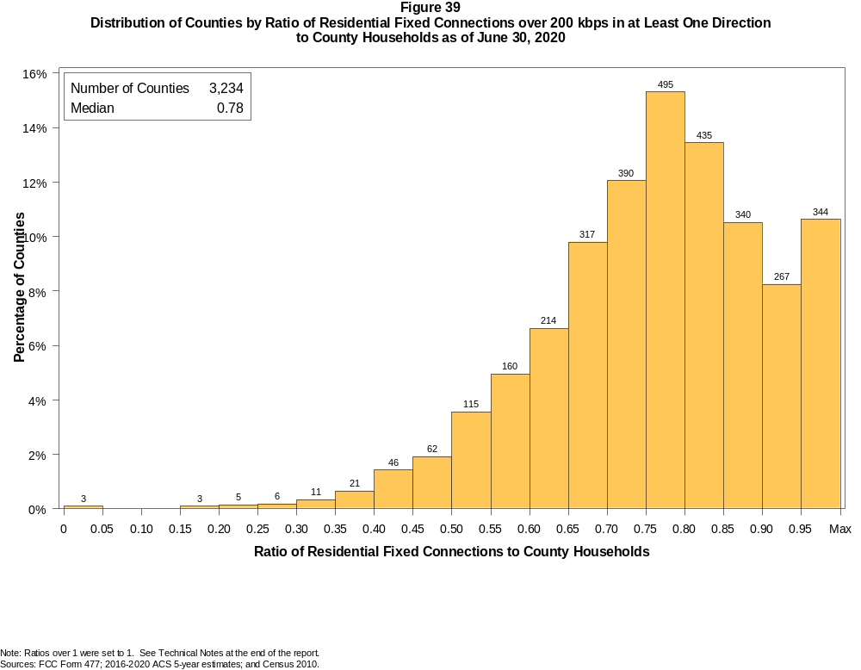

Figure 40
Distribution of Counties by Ratio of Residential Fixed Connections over 200 kbps in at Least One Direction
to County Households by Technology as of June 30, 2020

 | Ratio of Residential Fixed Connections to County Households
Technology | Zero | Greater than 0 and no more than 5% | Greater than 5 and no more than 10% | Greater than 10 and no more than 20% | Greater than 20 and no more than 30% | Greater than 30 and no more than 40% | Greater than 40 and no more than 50% | Greater than 50 and no more than 60% | Greater than 60 and no more than 80% | Greater than 80 and no more than 100% | 100% or more
aDSL | 1.8 | 8.8 | 11.5 | 31.1 | 23.5 | 12.8 | 6.0 | 2.3 | 1.9 | 0.2 | 0.2
sDSL | 95.1 | 4.9 | 0.1 | 0.0 | 0.0 | 0.0 | 0.0 | 0.0 | 0.0 | 0.0 | 0.0
Other Wireline¹ | 85.1 | 14.8 | 0.1 | 0.0 | 0.0 | 0.0 | 0.0 | 0.0 | 0.0 | 0.0 | 0.0
Cable Modem | 10.0 | 7.2 | 5.3 | 11.5 | 13.1 | 11.8 | 11.3 | 11.3 | 15.6 | 2.3 | 0.7
FTTP | 11.9 | 42.2 | 13.0 | 12.1 | 7.1 | 4.2 | 3.3 | 2.2 | 3.5 | 0.5 | 0.1
Satellite | 0.4 | 64.1 | 22.6 | 11.3 | 1.1 | 0.4 | 0.1 | 0.0 | 0.0 | 0.0 | 0.0
Fixed Wireless | 12.2 | 59.7 | 13.4 | 9.3 | 3.3 | 1.2 | 0.6 | 0.1 | 0.1 | 0.0 | 0.1
Total | 0.1 | 0.0 | 0.0 | 0.1 | 0.3 | 1.0 | 3.3 | 8.5 | 43.8 | 37.0 | 5.9

¹ Power Line and Other are summarized with Other Wireline. See Technical Notes at the end of the report for a description of FCC Form 477 technology categories and other reporting requirements.
Note: Numbers may not sum to totals due to rounding.
Sources: FCC Form 477; 2016-2020 ACS 5-year estimates; and Census 2010.

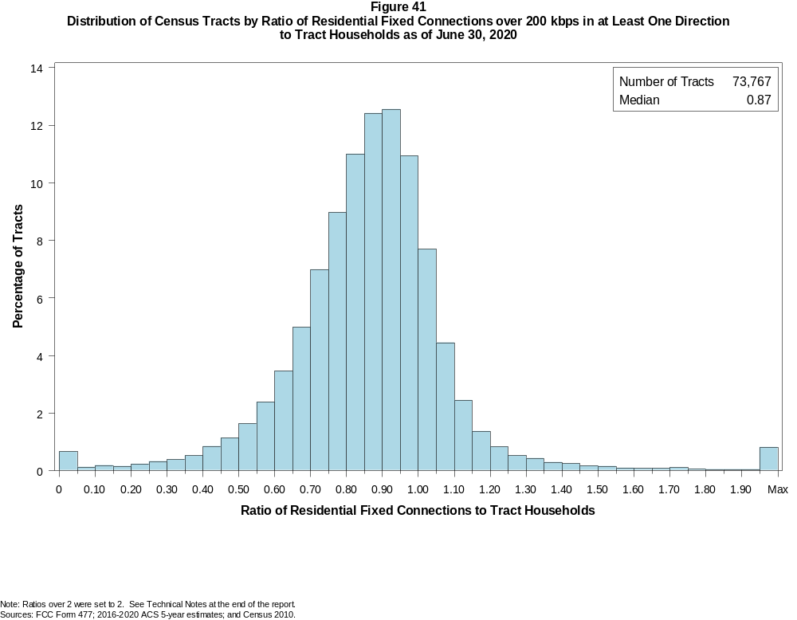

Figure 42
Distribution of Census Tracts by Ratio of Residential Fixed Connections over 200 kbps in at Least One Direction
to Tract Households by Technology as of June 30, 2020

 | Ratio of Residential Fixed Connections to Tract Households
Technology | Zero | Greater than 0 and no more than 5% | Greater than 5 and no more than 10% | Greater than 10 and no more than 20% | Greater than 20 and no more than 30% | Greater than 30 and no more than 40% | Greater than 40 and no more than 50% | Greater than 50 and no more than 60% | Greater than 60 and no more than 80% | Greater than 80 and no more than 100% | 100% or more
aDSL | 4.4 | 27.1 | 16.0 | 24.8 | 15.9 | 6.4 | 2.8 | 1.3 | 0.9 | 0.2 | 0.2
sDSL | 99.4 | 0.6 | 0.0 | 0.0 | 0.0 | 0.0 | 0.0 | 0.0 | 0.0 | 0.0 | 0.0
Other Wireline¹ | 97.6 | 2.2 | 0.1 | 0.1 | 0.0 | 0.0 | 0.0 | 0.0 | 0.0 | 0.0 | 0.0
Cable Modem | 4.2 | 2.8 | 1.5 | 3.3 | 4.5 | 7.4 | 12.8 | 17.5 | 31.6 | 11.5 | 3.0
FTTP | 31.1 | 23.2 | 8.3 | 11.5 | 8.0 | 6.4 | 4.9 | 3.0 | 2.8 | 0.5 | 0.2
Satellite | 25.7 | 64.0 | 5.5 | 3.7 | 0.8 | 0.2 | 0.1 | 0.0 | 0.0 | 0.0 | 0.0
Fixed Wireless | 65.4 | 26.7 | 3.2 | 2.6 | 1.0 | 0.5 | 0.2 | 0.1 | 0.1 | 0.0 | 0.0
Total | 0.6 | 0.1 | 0.1 | 0.3 | 0.6 | 0.9 | 2.0 | 4.0 | 24.4 | 47.0 | 20.0

¹ Power Line and Other are summarized with Other Wireline. See Technical Notes at the end of the report for a description of FCC Form 477 technology categories and other reporting requirements.
Note: Numbers may not sum to totals due to rounding.
Sources: FCC Form 477; 2016-2020 ACS 5-year estimates; and Census 2010.

Figure 43
Percentage of Developed Census Blocks with Residential Fixed Service by Technology as of June 30, 2020
(Internet Access Service over 200 kbps in at least one direction)

 | Number of Providers
Technology | Zero | One | Two | Three | Four | Five | Six | Seven or More
aDSL | 22.9 | 75.1 | 1.9 | 0.1 | 0.0 | 0.0 | 0.0 | 0.0
sDSL | 99.6 | 0.4 | 0.0 | 0.0 | 0.0 | 0.0 | 0.0 | 0.0
Other Wireline¹ | 99.3 | 0.7 | 0.0 | 0.0 | 0.0 | 0.0 | 0.0 | 0.0
Cable Modem | 31.9 | 64.1 | 3.9 | 0.0 | 0.0 | 0.0 | 0.0 | 0.0
FTTP | 70.2 | 28.0 | 1.6 | 0.1 | 0.0 | 0.0 | 0.0 | 0.0
Satellite | 0.0 | 0.1 | 1.0 | 98.8 | 0.0 | 0.0 | 0.0 | 0.0
Fixed Wireless | 46.6 | 28.0 | 15.8 | 6.6 | 2.4 | 0.6 | 0.1 | 0.0
aDSL and/or Cable Modem and/or FTTP | 10.4 | 24.2 | 56.1 | 8.8 | 0.5 | 0.1 | 0.0 | 0.0
Any Technology | 0.0 | 0.1 | 0.0 | 3.4 | 13.8 | 39.0 | 24.4 | 19.3

¹ Power Line and Other are summarized with Other Wireline. See Technical Notes at the end of the report for a description of FCC Form 477 technology categories and other reporting requirements.
Note: Numbers may not sum to totals due to rounding. The number of providers in a census block does not necessarily reflect the number of choices available to a particular household, and does not
purport to measure competition. Providers may list a census block on FCC Form 477 if service can be provided to at least one location in the block. Developed census blocks are those with housing units
based on the 2010 census.
Sources: FCC Form 477 and Census 2010.

Figure 44
Distribution of Counties by Ratio of Residential Fixed Connections to County Households by State as of June 30, 2020
(Connections over 200 kbps in at least one direction)

 |  | Ratio of Residential Fixed Connections over 200 kbps in at Least One Direction to County Households
State | Counties | Zero | Greater than 0 and no more than 5% | Greater than 5 and no more than 10% | Greater than 10 and no more than 20% | Greater than 20 and no more than 30% | Greater than 30 and no more than 40% | Greater than 40 and no more than 50% | Greater than 50 and no more than 60% | Greater than 60 and no more than 80% | Greater than 80 and no more than 100% | 100% or more
Alabama | 67 | 0 | 0 | 0 | 0 | 1 | 0 | 7 | 9 | 34 | 16 | 0
Alaska | 29 | 0 | 0 | 0 | 1 | 0 | 0 | 2 | 2 | 6 | 13 | 5
American Samoa | 5 | 2 | 0 | 0 | 0 | 0 | 0 | 2 | 0 | 1 | 0 | 0
Arizona | 15 | 0 | 0 | 0 | 0 | 0 | 0 | 1 | 0 | 7 | 7 | 0
Arkansas | 75 | 0 | 0 | 0 | 0 | 0 | 1 | 7 | 22 | 36 | 9 | 0
California | 58 | 0 | 0 | 0 | 0 | 0 | 0 | 0 | 0 | 8 | 45 | 5
Colorado | 64 | 0 | 0 | 0 | 0 | 0 | 0 | 3 | 4 | 18 | 23 | 16
Connecticut | 8 | 0 | 0 | 0 | 0 | 0 | 0 | 0 | 0 | 0 | 8 | 0
Delaware | 3 | 0 | 0 | 0 | 0 | 0 | 0 | 0 | 0 | 0 | 2 | 1
District of Columbia | 1 | 0 | 0 | 0 | 0 | 0 | 0 | 0 | 0 | 0 | 1 | 0
Florida | 67 | 0 | 0 | 0 | 0 | 0 | 0 | 0 | 2 | 20 | 25 | 20
Georgia | 159 | 0 | 0 | 0 | 0 | 1 | 4 | 11 | 20 | 66 | 47 | 10
Guam | 1 | 0 | 0 | 0 | 0 | 0 | 0 | 0 | 0 | 0 | 1 | 0
Hawaii | 5 | 0 | 0 | 0 | 1 | 0 | 0 | 0 | 0 | 0 | 1 | 3
Idaho | 44 | 0 | 0 | 0 | 0 | 0 | 1 | 1 | 4 | 19 | 13 | 6
Illinois | 102 | 0 | 0 | 0 | 0 | 1 | 0 | 1 | 9 | 60 | 31 | 0
Indiana | 92 | 0 | 0 | 0 | 0 | 0 | 0 | 0 | 8 | 57 | 27 | 0
Iowa | 99 | 0 | 0 | 0 | 0 | 0 | 0 | 0 | 0 | 67 | 29 | 3
Kansas | 105 | 0 | 0 | 0 | 0 | 0 | 0 | 1 | 5 | 64 | 35 | 0
Kentucky | 120 | 0 | 0 | 0 | 0 | 0 | 0 | 1 | 17 | 63 | 39 | 0
Louisiana | 64 | 0 | 0 | 0 | 0 | 0 | 1 | 7 | 13 | 26 | 17 | 0
Maine | 16 | 0 | 0 | 0 | 0 | 0 | 0 | 0 | 0 | 0 | 9 | 7
Maryland | 24 | 0 | 0 | 0 | 0 | 0 | 0 | 0 | 0 | 6 | 16 | 2
Massachusetts | 14 | 0 | 0 | 0 | 0 | 0 | 0 | 0 | 0 | 0 | 11 | 3
Michigan | 83 | 0 | 0 | 0 | 0 | 0 | 0 | 0 | 3 | 43 | 31 | 6
Minnesota | 87 | 0 | 0 | 0 | 0 | 0 | 0 | 1 | 1 | 26 | 55 | 4
Mississippi | 82 | 0 | 0 | 0 | 0 | 1 | 3 | 13 | 24 | 36 | 4 | 1
Missouri | 115 | 0 | 0 | 0 | 0 | 0 | 2 | 6 | 16 | 64 | 25 | 2
Montana | 56 | 0 | 0 | 0 | 0 | 0 | 0 | 0 | 1 | 27 | 26 | 2
Nebraska | 93 | 0 | 0 | 0 | 0 | 0 | 0 | 1 | 7 | 60 | 25 | 0

Figure 44 - Continued
Distribution of Counties by Ratio of Residential Fixed Connections to County Households by State as of June 30, 2020
(Connections over 200 kbps in at least one direction)

 |  | Ratio of Residential Fixed Connections over 200 kbps in at Least One Direction to County Households
State | Counties | Zero | Greater than 0 and no more than 5% | Greater than 5 and no more than 10% | Greater than 10 and no more than 20% | Greater than 20 and no more than 30% | Greater than 30 and no more than 40% | Greater than 40 and no more than 50% | Greater than 50 and no more than 60% | Greater than 60 and no more than 80% | Greater than 80 and no more than 100% | 100% or more
Nevada | 17 | 0 | 0 | 0 | 0 | 0 | 0 | 2 | 1 | 6 | 8 | 0
New Hampshire | 10 | 0 | 0 | 0 | 0 | 0 | 0 | 0 | 0 | 0 | 7 | 3
New Jersey | 21 | 0 | 0 | 0 | 0 | 0 | 0 | 0 | 0 | 0 | 18 | 3
New Mexico | 33 | 0 | 0 | 0 | 0 | 0 | 0 | 0 | 3 | 14 | 12 | 4
New York | 62 | 0 | 0 | 0 | 0 | 0 | 0 | 1 | 0 | 17 | 38 | 6
North Carolina | 100 | 0 | 0 | 0 | 0 | 0 | 0 | 0 | 2 | 34 | 55 | 9
North Dakota | 53 | 0 | 0 | 0 | 0 | 0 | 0 | 0 | 1 | 21 | 24 | 7
Northern Mariana Isl | 4 | 1 | 0 | 0 | 0 | 0 | 1 | 1 | 1 | 0 | 0 | 0
Ohio | 88 | 0 | 0 | 0 | 0 | 0 | 0 | 1 | 2 | 43 | 40 | 2
Oklahoma | 77 | 0 | 0 | 0 | 0 | 0 | 1 | 5 | 17 | 45 | 8 | 1
Oregon | 36 | 0 | 0 | 0 | 0 | 0 | 0 | 1 | 1 | 10 | 20 | 4
Pennsylvania | 67 | 0 | 0 | 0 | 0 | 0 | 0 | 0 | 1 | 24 | 37 | 5
Puerto Rico | 78 | 0 | 0 | 0 | 1 | 6 | 13 | 17 | 28 | 12 | 1 | 0
Rhode Island | 5 | 0 | 0 | 0 | 0 | 0 | 0 | 0 | 0 | 0 | 3 | 2
South Carolina | 46 | 0 | 0 | 0 | 0 | 0 | 0 | 0 | 5 | 22 | 17 | 2
South Dakota | 66 | 0 | 0 | 0 | 0 | 0 | 0 | 0 | 2 | 36 | 26 | 2
Tennessee | 95 | 0 | 0 | 0 | 0 | 0 | 0 | 0 | 3 | 64 | 27 | 1
Texas | 254 | 0 | 0 | 0 | 0 | 0 | 1 | 8 | 26 | 124 | 83 | 12
Utah | 29 | 0 | 0 | 0 | 0 | 0 | 0 | 0 | 0 | 3 | 18 | 8
Vermont | 14 | 0 | 0 | 0 | 0 | 0 | 0 | 0 | 0 | 0 | 10 | 4
Virgin Islands | 3 | 0 | 0 | 0 | 0 | 0 | 0 | 0 | 0 | 2 | 1 | 0
Virginia | 134 | 0 | 0 | 0 | 0 | 1 | 3 | 5 | 12 | 51 | 58 | 4
Washington | 39 | 0 | 0 | 0 | 0 | 0 | 0 | 1 | 0 | 9 | 24 | 5
West Virginia | 55 | 0 | 0 | 0 | 0 | 0 | 1 | 1 | 2 | 37 | 14 | 0
Wisconsin | 72 | 0 | 0 | 0 | 0 | 0 | 0 | 0 | 1 | 21 | 40 | 10
Wyoming | 23 | 0 | 0 | 0 | 0 | 0 | 0 | 0 | 1 | 6 | 15 | 1
Total | 3,234 | 3 | 0 | 0 | 3 | 11 | 32 | 108 | 276 | 1415 | 1195 | 191

Note: Numbers may not sum to totals due to rounding. See Technical Notes at the end of the report.
Sources: FCC Form 477; 2016-2020 ACS 5-year estimates (Households for U.S. and District of Columbia); Census 2010 (Households for Puerto Rico, American Samoa,
Guam, Northern Mariana Islands and U.S. Virgin Islands).

Figure 45
Distribution of Census Tracts by Ratio of Residential Fixed Connections to Tract Households by State as of June 30, 2020
(Connections over 200 kbps in at least one direction)

 |  | Ratio of Residential Fixed Connections over 200 kbps in at Least One Direction to Tract Households
State | Tracts | Zero | Greater than 0 and no more than 5% | Greater than 5 and no more than 10% | Greater than 10 and no more than 20% | Greater than 20 and no more than 30% | Greater than 30 and no more than 40% | Greater than 40 and no more than 50% | Greater than 50 and no more than 60% | Greater than 60 and no more than 80% | Greater than 80 and no more than 100% | 100% or more
Alabama | 1,179 | 0 | 0 | 1 | 3 | 9 | 47 | 63 | 129 | 413 | 393 | 121
Alaska | 167 | 1 | 0 | 0 | 3 | 1 | 4 | 6 | 5 | 39 | 73 | 35
American Samoa | 18 | 2 | 0 | 0 | 0 | 0 | 4 | 5 | 5 | 0 | 0 | 2
Arizona | 1,526 | 9 | 2 | 4 | 9 | 21 | 13 | 33 | 55 | 335 | 659 | 386
Arkansas | 686 | 0 | 0 | 0 | 1 | 7 | 19 | 77 | 106 | 259 | 180 | 37
California | 8,036 | 46 | 11 | 3 | 9 | 18 | 38 | 52 | 110 | 1,248 | 4,638 | 1,863
Colorado | 1,249 | 8 | 0 | 1 | 1 | 1 | 2 | 12 | 25 | 161 | 632 | 406
Connecticut | 829 | 3 | 0 | 0 | 1 | 1 | 0 | 2 | 4 | 111 | 527 | 180
Delaware | 215 | 1 | 0 | 0 | 0 | 1 | 0 | 0 | 3 | 36 | 94 | 80
District of Columbia | 179 | 0 | 0 | 0 | 2 | 0 | 0 | 0 | 4 | 33 | 87 | 53
Florida | 4,199 | 29 | 5 | 2 | 2 | 5 | 12 | 26 | 95 | 593 | 1,746 | 1,684
Georgia | 1,964 | 6 | 0 | 2 | 2 | 5 | 23 | 64 | 107 | 525 | 812 | 418
Guam | 56 | 8 | 1 | 1 | 4 | 4 | 1 | 3 | 3 | 8 | 8 | 15
Hawaii | 326 | 10 | 1 | 1 | 1 | 1 | 0 | 4 | 2 | 38 | 126 | 142
Idaho | 298 | 0 | 0 | 0 | 1 | 4 | 2 | 5 | 11 | 96 | 140 | 39
Illinois | 3,121 | 5 | 0 | 0 | 3 | 12 | 17 | 65 | 131 | 1,011 | 1,522 | 355
Indiana | 1,508 | 5 | 1 | 0 | 4 | 1 | 14 | 26 | 120 | 534 | 618 | 185
Iowa | 825 | 4 | 0 | 0 | 0 | 1 | 1 | 10 | 33 | 396 | 324 | 56
Kansas | 770 | 6 | 0 | 1 | 3 | 6 | 4 | 8 | 47 | 282 | 314 | 99
Kentucky | 1,115 | 6 | 1 | 2 | 0 | 4 | 14 | 32 | 63 | 382 | 495 | 116
Louisiana | 1,136 | 9 | 2 | 0 | 3 | 13 | 24 | 72 | 93 | 368 | 380 | 172
Maine | 351 | 0 | 0 | 0 | 0 | 0 | 0 | 0 | 2 | 53 | 172 | 124
Maryland | 1,394 | 6 | 1 | 1 | 1 | 2 | 5 | 15 | 27 | 223 | 664 | 449
Massachusetts | 1,471 | 12 | 1 | 1 | 0 | 1 | 5 | 3 | 13 | 190 | 909 | 336
Michigan | 2,767 | 26 | 2 | 5 | 5 | 19 | 36 | 62 | 168 | 738 | 1,310 | 396
Minnesota | 1,335 | 4 | 0 | 0 | 0 | 2 | 5 | 8 | 26 | 366 | 770 | 154
Mississippi | 661 | 4 | 0 | 0 | 1 | 8 | 26 | 78 | 124 | 249 | 139 | 32
Missouri | 1,393 | 3 | 1 | 0 | 2 | 12 | 17 | 58 | 108 | 456 | 573 | 163
Montana | 271 | 1 | 0 | 0 | 0 | 1 | 2 | 3 | 8 | 89 | 128 | 39
Nebraska | 532 | 3 | 1 | 0 | 0 | 1 | 0 | 2 | 20 | 192 | 248 | 65

Figure 45 - Continued
Distribution of Census Tracts by Ratio of Residential Fixed Connections to Tract Households by State as of June 30, 2020
(Connections over 200 kbps in at least one direction)

 |  | Ratio of Residential Fixed Connections over 200 kbps in at Least One Direction to Tract Households
State | Tracts | Zero | Greater than 0 and no more than 5% | Greater than 5 and no more than 10% | Greater than 10 and no more than 20% | Greater than 20 and no more than 30% | Greater than 30 and no more than 40% | Greater than 40 and no more than 50% | Greater than 50 and no more than 60% | Greater than 60 and no more than 80% | Greater than 80 and no more than 100% | 100% or more
Nevada | 683 | 3 | 0 | 0 | 1 | 1 | 4 | 13 | 16 | 128 | 350 | 167
New Hampshire | 294 | 2 | 0 | 0 | 0 | 0 | 0 | 1 | 1 | 12 | 166 | 112
New Jersey | 2,004 | 9 | 1 | 1 | 2 | 2 | 6 | 8 | 13 | 256 | 1,092 | 614
New Mexico | 499 | 1 | 2 | 1 | 2 | 7 | 9 | 17 | 22 | 170 | 205 | 63
New York | 4,900 | 68 | 3 | 6 | 18 | 17 | 16 | 39 | 79 | 1,198 | 2,494 | 962
North Carolina | 2,183 | 12 | 1 | 0 | 0 | 1 | 4 | 11 | 70 | 572 | 915 | 597
North Dakota | 205 | 0 | 0 | 0 | 0 | 0 | 1 | 1 | 7 | 70 | 88 | 38
Northern Mariana Isl | 22 | 2 | 0 | 0 | 0 | 2 | 4 | 6 | 1 | 5 | 2 | 0
Ohio | 2,946 | 5 | 0 | 0 | 4 | 7 | 18 | 61 | 130 | 880 | 1,472 | 369
Oklahoma | 1,046 | 0 | 2 | 2 | 5 | 11 | 30 | 60 | 138 | 368 | 309 | 121
Oregon | 827 | 2 | 0 | 0 | 1 | 0 | 1 | 5 | 19 | 163 | 515 | 121
Pennsylvania | 3,217 | 17 | 3 | 3 | 5 | 4 | 12 | 29 | 87 | 857 | 1,717 | 483
Puerto Rico | 903 | 13 | 15 | 49 | 132 | 140 | 130 | 138 | 64 | 70 | 38 | 114
Rhode Island | 241 | 0 | 0 | 1 | 0 | 0 | 0 | 1 | 1 | 21 | 155 | 62
South Carolina | 1,097 | 9 | 0 | 1 | 0 | 13 | 10 | 36 | 70 | 309 | 404 | 245
South Dakota | 222 | 0 | 0 | 0 | 1 | 0 | 1 | 4 | 7 | 89 | 92 | 28
Tennessee | 1,497 | 12 | 2 | 0 | 3 | 5 | 10 | 36 | 105 | 533 | 628 | 163
Texas | 5,253 | 30 | 2 | 2 | 4 | 16 | 40 | 120 | 288 | 1,565 | 2,114 | 1,072
Utah | 588 | 2 | 2 | 0 | 2 | 2 | 2 | 0 | 12 | 80 | 330 | 156
Vermont | 184 | 1 | 0 | 0 | 0 | 0 | 0 | 1 | 1 | 17 | 108 | 56
Virgin Islands | 29 | 0 | 1 | 0 | 2 | 4 | 5 | 2 | 2 | 6 | 2 | 5
Virginia | 1,895 | 18 | 1 | 2 | 2 | 11 | 27 | 43 | 84 | 390 | 865 | 452
Washington | 1,446 | 1 | 1 | 1 | 1 | 2 | 3 | 8 | 17 | 188 | 916 | 308
West Virginia | 484 | 0 | 1 | 1 | 8 | 9 | 12 | 24 | 46 | 197 | 150 | 36
Wisconsin | 1,393 | 2 | 2 | 0 | 1 | 2 | 3 | 7 | 31 | 419 | 772 | 154
Wyoming | 132 | 1 | 0 | 1 | 0 | 0 | 0 | 2 | 2 | 34 | 75 | 17
Total | 73,767 | 427 | 69 | 96 | 255 | 417 | 683 | 1,467 | 2,960 | 18,021 | 34,655 | 14,717

Note: Numbers may not sum to totals due to rounding. See Technical Notes at the end of the report.
Sources: FCC Form 477; 2016-2020 ACS 5-year estimates (Households for U.S. and District of Columbia); Census 2010 (Households for Puerto Rico, American Samoa,
Guam, Northern Mariana Islands and U.S. Virgin Islands).

